

**Team 01: Bluegrass Bourboneering**

**Final Design Report**

**Team Members:**

Mitchell Maddix

Joshua McCarty

Craig Tate

Matthew Walker

Trevor Veenstra

Seth Damron

mitchell.maddix@uky.edu

joshua.mccarty@uky.edu

cdta229@uky.edu

mawa252@uky.edu

tve229@uky.edu

seth.damron52@uky.edu

**Project Advisors:**

Dr. Regina Hannemann regina.hannemann@uky.edu

Dr. Daniel Lau dllau@uky.edu

Dr. Robert Adams robert.adams@uky.edu

Dr. John Young john.c.young@uky.edu

**Project Sponsor:**

Bardstown Bourbon Company

**Mentors:**

Roger Henley

Thomas Pile

**Date:**

April 19, 2021

**Table of Contents:**

1. *Abstract* …………………………………………………………………………………………..3
2. *Problem Statement* ……………………………………………………………………………….4
   1. *Need* ……………………………………………………………………………………..4
   2. *Objective* ………………………………………………………………………………...4
   3. *Background* ……………………………………………………………………………...4
   4. Technology Survey……………………………………………………….……………...4
3. *Requirements Specification* ……………………………………………………………………...5
   1. *Marketing Requirements* ………………………………………………………………...5
   2. *Objective Tree* …………………………………………………………………………...5
   3. *Engineering Requirements* ……………………………………………………………....7
   4. *Design Impact* …………………………………………………………………………...10
      1. *Economic*………………………………………………………………… …….10
      2. *Political*……………………………………………………………………….... 10
      3. *Health and Safety* ……………………………………………………………….10
      4. *Manufacturability* ……………………………………………………………….10
      5. *Standards* ………………………………………………………………………..10
4. *Design* …………………………………………………………………………………………….11
   1. *Design Overview* ………………………………………………………………………...11
   2. *Function Decomposition* …………...……………………………………………………11
      1. *Function Decomposition Changes*…………………………..………………….11
      2. *Level 0* …………………………………………………………………………..11
      3. *Level 1*…………………………………………………………………………..12
      4. *Level 2* ……………………………………………………………………..……13
      5. *Level 3*…………………………………………………………………………..14
   3. *Subsystem Selection*……………………………………………………………………..14
      1. *Human Machine Interface*………………………………………………………15
      2. *Control Algorithm*……………………………………………………………….23
      3. *Automation*……………………………………………………………………....29
      4. *Programmable Logic Controller*………………………………………………...32
      5. *Sensing Elements* ………………………………………………………………..37
5. *Design Integration, Verification, and Validation*…...…………………………………………….45
   1. HMI/PLC Testing…………………………………………………………………...…...46
   2. Control ALgorithm Testing……………………………………………………………...46
      1. Comparison of Volumetric Formula and Tabular Method……………………...50
6. *Project Plan* …………………………………………………………………………………...….50
   1. *Work Breakdown*……………………….………………………………………………...50
   2. *Gantt Chart*……………………...…………………………………………………….....52
   3. *Cost Analysis*……… …………………………………………………………………….55
   4. *Team Member Responsibilities* ………………………………….……..………………...55
7. *References* ………………………………………………………………………………………..57
8. *Appendix A* ……...…………………………………...………………………...…………....…....59
9. *Appendix B* ……...…………………………………...………………………...…………....…....64

**List of Figures:**

*Figure 3.1*. …………………………………………………………………………………………………..7

*Figure 4.1*.. ………………………………………………………………………………………………...11

*Figure 4.2*.. ………………………………………………………………………………………………...12

*Figure 4.3*.. ………………………………………………………………………………………………...13

*Figure 4.4*.. ………………………………………………………………………………………………...14

*Figure 4.5*.. ………………………………………………………………………………………………...15

*Figure 4.6*.. ………………………………………………………………………………………………...17

*Figure 4.7*.. ………………………………………………………………………………………………...18

*Figure 4.8*.. ………………………………………………………………………………………………...20

*Figure 4.9*.. ………………………………………………………………………………………………...21

*Figure 4.10*. ………………………………………………………………………………………………..21

*Figure 4.11* ………………………………………………………………………………………………...22

*Figure 4.12*.. ……………………………………………………………………………………………….23

*Figure 4.13*.. ..……………………………………………………………………………………………...27

*Figure 4.14*………………………………………………………………………………………………...30

*Figure 4.15*………………………………………………………………………………………………...30

*Figure 4.16*………………………………………………………………………………………………...32

*Figure 4.17*………………………………………………………………………………………………...33

*Figure 4.18*………………………………………………………………………………………………...33

*Figure 4.19*………………………………………………………………………………………………...34

*Figure 4.20*………………………………………………………………………………………………...35

*Figure 4.21*………………………………………………………………………………………………...36

*Figure 4.22*………………………………………………………………………………………………...37

*Figure 4.23*………………………………………………………………………………………………...38

*Figure 4.24*………………………………………………………………………………………………...38

*Figure 4.25*………………………………………………………………………………………………...39

*Figure 4.26*………………………………………………………………………………………………...41

*Figure 4.27*………………………………………………………………………………………………...44

*Figure 5.1*.. ………………………………………………………………………………………………...45

*Figure 5.2*.. ………………………………………………………………………………………………...47

*Figure 5.3*.. ………………………………………………………………………………………………...48

*Figure 5.4*.. ………………………………………………………………………………………………...49

*Figure 6.1*.. ………………………………………………………………………………………………...53

*Figure 6.2*.. ………………………………………………………………………………………………...53

*Figure 6.3*.. ………………………………………………………………………………………………...54

*Figure 6.4*.. ………………………………………………………………………………………………...54

*Figure 6.5*.. ………………………………………………………………………………………………...54

*Figure 1.B*.. ………………………………………………………………………………………………...65

*Figure 2.B*.. ………………………………………………………………………………………………...66

**List of Tables:**

*Table 3.1* …………………………………………………………………………………………………….5

*Table 3.2* ..……………………...…………………………………………………………………………...7

*Table 4.1* ..……………………...………………………………………………………………………….25

*Table 4.2* ..……………………...………………………………………………………………………….25

*Table 4.3* ..……………………...………………………………………………………………………….26

*Table 4.4* ..……………………...………………………………………………………………………….26

*Table 4.5* ..……………………...………………………………………………………………………….31

*Table 4.6* ..……………………...………………………………………………………………………….39

*Table 4.7* ..……………………...………………………………………………………………………….41

*Table 4.8* ..……………………...………………………………………………………………………….42

*Table 4.9* ..……………………...………………………………………………………………………….45

*Table 6.1* ..……………………...………………………………………………………………………….50

*Table 6.2* ..……………………...………………………………………………………………………….55

*Table 6.3* ..……………………...………………………………………………………………………….56

*Table 6.4* ..……………………...………………………………………………………………………….57

*Table 1A* .…………………………………………………………………………………………………..59

*Table 2A* .…………………………………………………………………………………………………..61

*Table 3A* .…………………………………………………………………………………………………..61

*Table 4A* .…………………………………………………………………………………………………..62

*Table 5A* .…………………………………………………………………………………………………..62

*Table 6A* .…………………………………………………………………………………………………..62

*Table 7A* .…………………………………………………………………………………………………..63

*Table 8A* .…………………………………………………………………………………………………..63

1. **Abstract**

Bardstown Bourbon Company, or BBC, is building a new state-of-the-art bottling facility. Aged bourbon will enter this facility by barrel to be emptied into a trough. After many barrels have been emptied, the bourbon flows from the trough, through pipes, to a large cistern. The alcoholic proof of the collected liquid is measured and recorded. The collected bourbon’s alcoholic proof must be diluted to a selected amount for bottling and sale as a product. Reverse osmosis water is mixed with the bourbon to accomplish this. When the desired proof is reached, the bourbon is ready to be emptied out of the cistern and sent to the bottle filling machine for bottling. BBC has tasked our team with designing the control system that reduces the bourbon’s proof before it is bottled. The control system consists of a human-machine interface (HMI) and a Programmable Logic Controller (PLC). The HMI will display information that is received from the PLC. The PLC is the electrical interface that communicates with the sensors on the system. The sensor data will be displayed on the HMI. The proof of a tank will be measured and entered into the HMI manually. The user will then be able to enter the desired proof level into the HMI, it will then calculate and display to the user what needs to be done to reduce the proof of the bourbon. Once the bourbon is at the desired proof it will be pumped to bottling and conclude our part of the process. This report details our team’s problem statement and requirements specification.

1. **Problems Statement**
   1. **Need**

Bardstown Bourbon Company currently sends the bourbon they distill to another business to be bottled and distributed for sale. To keep production and bottling costs low, BBC is constructing a bottling facility of their own. The new facility requires a system to dilute the high proof bourbon by mixing it with reverse osmosis (RO) water. The bourbon is to be reduced to a level set by BBC or a co-manufacturing partner. BBC is looking for Bluegrass Bourboneering to design and create a control system for the liquid diluting component of the bottling facility.

* 1. **Objective**

The objective of this project is to design and implement a control system for the bourbon dilution portion of a bottling facility. This system is to take high proof bourbon and dilute it to a desired amount by adding reverse osmosis (RO) water. The system must use the measured proof of the bourbon and calculate the needed RO water. The system needs to be operated and analyzed through a human machine interface, or HMI.

* 1. **Background**

According to the Kentucky Distillers Association, Bourbon is the only native spirit to the United States [1]. To maintain its uniformity and pristine quality, bourbon is regulated to be made from 51% corn at a range of 125 to 80 proof [1]. Bourbon is also a signature industry for the state of Kentucky. The KDA also stated that bourbon is an $8.6 billion industry and is able to create more than 20,000 jobs[1]. In the next five years, there is an estimated $2.3 billion in capital projects to be completed or are planned for new distilleries, state-of-the-art bottling facilities, and tourism centers[1].

Currently, Bardstown Bourbon Company is sending their bourbon to a different business to be bottled. To save cost and increase profit margins and expand their capabilities, BBC is constructing a new state-of-the-art bottling facility that is set to open mid-May. This facility is going to take bourbon from a tanker truck or straight from the barrel, process it, and bottle it for retail sale.

* 1. **Technology Survey**

The individual technologies that will be used in this design project have long existed in industrial production environments. The HMI and PLC technology already exist and are used to drive industrial automation. The task that we must accomplish with these two technologies is cutting the proof of bourbon down before bottling. This will be assisted by several electronic devices.

The electronic devices that will be used in combination with the HMI and PLC are as follows. Load cells that will be used to determine the weight of the cisterns. A flow rate sensor to determine the density and the flow rate of a liquid. An in-line proofing sensor to determine the alcohol content of the bourbon entering a cistern. These electronic devices will be connected to the PLC which will interpret the data and from there it can be displayed to the user at the HMI display screen.

1. **Requirements Specification**
   1. **Marketing Requirements**

**Table 3.1:** Marketing Requirements

|  |  |
| --- | --- |
| **Index:** | **Marketing Requirements:** |
| 1 | The HMI shall be hardwired into their local network |
| 2 | The HMI display should be user friendly |
| 3 | The HMI shall use Ignition (HMI) software |
| 4 | The PLC shall use Studio 5000 software |
| 5 | The HMI shall record all user commands given and store them on the local network |
| 6 | The PLC shall detect the weight of the cistern via the PLC |
| 7 | The HMI shall allow user input for current proof level |
| 8* | The PLC shall be able to control cistern ~~agitators~~, pumps, ~~and valves~~ |
| 9 | The HMI shall calculate in pounds (lbs) of RO water to add to produce desired proof |

*Marketing Requirement 8 originally included controlling the agitators and valves, but Sponsor feedback led to us only controlling the cistern pumps.

* 1. **Objective Tree**

The objective tree seen below in Figure 1 is from the marketing requirements above. The objective tree was divided into four broad major categories which form the top level of the objective tree. These categories are software, data reception, functional, and user compatible. From these four main categories the branches of each main category were formed. These are where the marketing requirements relate to each objective in the tree. Every requirement in the objective tree was assigned a weighting based on their respective main category. The importance of each main category is shown in the weighting. These weightings are referenced in appendix A.

By observing the weightings seen below the HMI’s functional capabilities and data reception are of equal weight and of most importance. This is because they contain over 50% of the marketing requirements. These categories make up the majority of the requirements requested by the sponsors for the project. The sponsor wants the device to be hardwired into their local network and for all commands given to the device to be stored in their database. The device will be connected to a PLC which will transmit data from the load sensors to the HMI. The PLC is connected to the cistern hardware which consists of agitators, pumps, and valves. This data will be sent and displayed to the user of the HMI. The HMI will also handle the RO water weight calculation once the proof has been entered by the user into the HMI. The 3rd most important main category is user compatibility. The display must be user friendly and allow input from the user in a straightforward way. The least important of the main categories is software. This was chosen as least important because the software to be used is specified by the sponsor and restricted by limitations of the PLC.

The first category of software is divided into two subcategories, Ignition and Studio 5000. Ignition is the HMI programming software which is already used by all of their HMIs. Studio 5000 is a PLC programming software that acts as a mediary between electrical hardware and the HMI display. Due to the dependence of these two in terms of operation they are weighted the same..

The information that the user inputs to the system and the system outputs back to the user require a clear path with no interrupts. This information must then be stored for future recollection in the event of repeatability or error detection. The clear path of communication in the system is accomplished with the use of Cat 6 cabling versus the alternative of wireless communication. As long as there is no damage to the Cat 6 cable and the end user understands the positioning of cabling, the system can minimize interruptions in communication. The event information can then be stored locally on an internal database with the use of timestamps and user identification.

Next to data reception and storage, functionality of the system is of comparable importance. Functionality for this design is broken into three sub categories; RO water weight calculations, the hardware of the cistern (meters, pumps, valves and agitators) and weight sensors. The weight sensors will take two measurements - one while the cistern is empty and the other after the cistern has been filled with alcohol to derive the total weight of alcohol. The user will input which valves to open and initiate the pumps to begin pumping alcohol to the appropriate cistern. While the alcohol is flowing, the flow sensors will measure the total amount of fluid entering the cistern. The user can then stop the flow when desired by disengaging appropriate hardware. The total fluid amount and weight will then be utilized in the RO water calculation to determine the proof and total amount of RO water to be pumped into the system. After the user has finished pumping in the desired amount of RO water, the agitators can be engaged to ensure a thorough mix of the RO water and bourbon contained in the cistern. Contents will then be manually sampled for proof testing and results will again be entered into RO water calculation to determine the need for additional RO water.

The human machine interface must also be user compatible, which is 14% of our marketing requirement: the user friendliness is 3% and the user input capability is 7%. The user friendliness means that a user is able to operate and understand the HMI with minimal training. It also implies an operator can use the HMI to accomplish their job in a minimal amount of time. They would not be wasting time navigating through menu after menu. This is because the setting, menus, readings, inputs, and outputs are in a logical place on the screen. The user input capability means that the HMI is capable of receiving typed alcoholic proof measurements from the operator. The user inputs should be recorded and used for the dilution process.

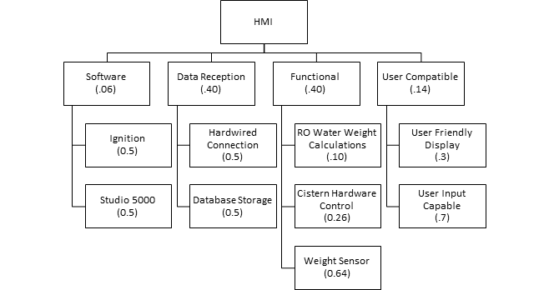

**Figure 3.1:** Controls System Objective Tree

* 1. **Engineering Requirements**

**Table 3.2:** Engineering Requirements

|  |  |  |  |  |
| --- | --- | --- | --- | --- |
| #: | **Engineering Requirements** | **Marketing Requirement #** | **Rationale** | **Verification** |
| 1. | Device shall communicate via CAT6 Cable. | 1 | Sponsor directed as such. | Upon installation of cable, shall verify that data traffic can occur between device and system. |
| 2. | Proofing shall be adjusted using RO water. | 6 | BBC maintains a tolerance of ±0.3 of the proof listed on the bottle. RO water is pure water that won’t chemically change the bourbon. | Inspect the bourbon after adding the RO water which will be done in-house at their analytical chemical laboratory with equipment. |
| 3. | Ignition programming software shall be used in order to program the HMI displays. | 3 | Ignition is the software that BBC uses for their HMI’s. | Upon inspection of the HMI in real time and after it has been integrated into BBC’s network because if it were not Ignition it would not be compatible. |
| 4. | Studio 5000 software shall be used for PLC programming. | 4 | Studio 5000 is the software that BBC uses for their PLC programming. | Upon inspection of ladder logic by opening up the program itself on a computer because if it were not Studio 5000 it would not be compatible. |
| 5. | Load sensors shall be used on each of the four legs of the cistern to measure the weight of its liquid contents. | 6 | Knowing the weight of bourbon in each cistern is critical in determining how much RO water that needs to be added to reduce it’s proof. | Upon testing that the load sensors can communicate within the HMI/PLC network. Also verifying their accuracy by zeroing them out and testing against a known weight. |
| 6.* | ~~Agitators shall be used to mix the bourbon with the RO water.~~ | ~~8~~ | ~~The bourbon must be mixed with the RO water before being retested to determine new proof level.~~ | ~~Inspection of alcohol proof after agitator activation and visual inspection that the agitators are mixing the bourbon.~~ |
| 7. | Code shall be well documented. | 2,3 | Documentation is needed for future viewing of the code that will make it easy to determine what does what. | Inspect documenting for depth and accuracy. |
| 8. | Display should be easy to read and layout will represent the entire process. | 2 | This makes it easy to determine what stage the process is in and what is currently going on with the system. | Users are able to operate the system from HMI with ease. Verify all required data and functions are displayed by inspection. |
| 9. | MySQL Workbench shall be used as the database. | 4 | This is the standard language for relational database management systems. | Inputting a value and verifying if the value is loaded onto the database because if MySQL were not used there would be no database. |
| 10. | Liquid flow rate meters shall be used to accurately measure the flow rate/density of RO water and bourbon. | 9 | Will allow for proofing calculations to be more accurate and reliable, preventing over dilution of proofing. | Time a known volume of liquid through the sensor and compare to sensor results. Flow a liquid of known density through the sensor and compare to sensor output for accuracy. |
| 11. | The proof shall not exceed ±0.3 percent from desired. | 7 | This is a tolerance that is hard set by the governing bodies and must be achieved. | Upon an attempt to adjust the current proof of the bourbon to the desired proof. BBC will verify the accuracy of our process in their chemistry lab. |
| 12. | Once the bourbon in a cistern has reached the desired proof, it should be marked as completed/ready in the HMI. | 4,5 | This prevents any further modifications to the completed proof. | Upon inputting the desired proof and the actual proof into the HMI. If they match then the cistern should be marked as finished. |
| 13. | Cisterns marked as completed/ready in the HMI should send their contents to the next stage of the process when prompted. | 7 | Will free cisterns so that the entire process can be repeated for future batches. | Initiate the prompt that the next stage is ready for transfer and verify that the process is taking place. |
| 14. | PLC integration shall be used to control activation/deactivation of pumps in order to pump bourbon to the next stage of bottling. | 8 | Will allow for automation of the pumping of alcohol. | Upon inspection that the PLC can control the activation/deactivation of the connected pumps and that they produce a movement of fluid. |
| 15. | HMI shall calculate the amount of RO water to add based on a user entered value of current proof level. | 9 | Will eliminate human error during the calculation to determine the amount of RO water needed. | Mix the calculated RO water with the bourbon then compare the new proof and the desired proof using laboratory equipment to ensure accurate dilution. |
| 16.* | ~~PLC integration shall be used to control activation/deactivation of valves to control flow of bourbon.~~ | ~~8~~ | ~~Will allow for automation of the flow of alcohol.~~ | ~~Upon inspection that the PLC can control the activation/deactivation of the connected valves and that they can control the flow of bourbon.~~ |

*Engineering Requirements numbers 6 and 16 have changed because the Marketing Requirement number 8 was changed.

* 1. **Design Impact**

In addition to marketing requirements and engineering requirements there are additional constraints on the project that must be considered. The constraints that were chosen for this project are economic, political, health and safety, manufacturability, and standards.

**3.4.1 Economic**

Bourbon is a very lucrative industry that is fast-growing, specifically seeing a 115% increase in production over the last 5 years [1]. In order to meet the increased demand, distilleries need to increase the output of bottled bourbon. The design shall allow for an efficient process of diluting the alcohol to specified tolerance. Any lag in the system is costly to the customer and must be mitigated. As a result the measurements and mixtures must be accurate and expedient. This requires more expenditures for the design in the form of: higher quality meters, pumps and scales. Maximum allotment for ROI is 3 years.

**3.4.2 Political**

The design has political constraints that must be abided by in the design. In the United States, alcoholic beverages are governed by the Alcohol and tobacco Tax and Trade Bureau, TTB for short. The TTB has legal guidelines for the bottling and labeling of bourbon. There is a tight tolerance of 0.3% of the labeled proof. If the spirit exceeds these limits, one can be fined for false advertisement. Thus, our system must ensure an accurate calculation of the alcoholic proof or risk fines.

**3.4.3 Health and Safety**

Health and safety is a very important constraint for our design. Our design must be accurate in the proofing measurements. If the proofing measurements are incorrect then a higher percentage alcohol could be distributed. Higher proof alcohol consumption could result in physical harm to the consumer. As a result the design must utilize sensors with a tighter tolerance and have verifiable measurements that are repeatable. Also, the system must operate in a timely manner to prevent long periods of wait time where the chance of contamination could occur. The contamination may lead to a health hazard.

**3.4.4 Manufacturability**

The manufacturability constraints of our design should be taken into consideration. The sensors and PLC equipment are multiple thousands of dollars and our design must use several of them. The budget for our project is the same as the bottling facility itself, so it’s important to ensure the most economical ones are selected that still meet the other requirements. The design also shall utilize displays to portray what is occurring in the system through the use of PLCs. The linking of the displays to the PLCs shall be done with the use of CAT6 cabling. The CAT6 cabling shall also be used to connect the PLCs to the individual electrical meters being used.

**3.4.5 Standards**

The final design constraint is the system needs to be compatible with pre-existing infrastructure standards created for the other systems at BBC. These standards ensure the upgradability and compatibility and maintenance of the system. The system should complete the diluting process before bottling while updating the company’s database through existing network protocols. The data uploaded must reflect accurately the inputs/outputs in real time. The database information must also be relayed to the operator through a human machine interface.

1. **Design**
   1. **Design Overview**

The overall project design at the highest level is a bourbon dilution control system. The control system will take in user input and sensor data to determine the amount of RO water to add to the cistern. This will result in reducing the alcohol content of the bourbon.

* 1. **Functional Decomposition**
     1. **Functional Decomposition Changes**

The functional decomposition had to undergo some changes after the initial meeting with our sponsor at the start of the semester. We learned that they were not interested in going with the automation that we had planned in our design. This bottling facility is a new business endeavor for our sponsor and they are not wanting to spend a large amount of money to add the automation to the control system.

The first change to the functional decomposition was changing the proof as a sensor input to a manually inputted value that the user enters into the HMI. The second change was the removal of the automation subsystem and its replacement as the cistern elements subsystem. This new subsystem will only contain the pumps of the cisterns. This will all be seen below in the modified functional decomposition diagrams.

* + 1. **Level 0**

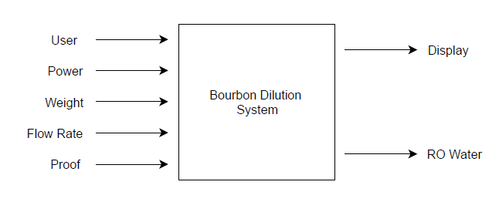

**Figure 4.1:** Level 0 Functional Decomposition

The level 0 function decomposition (Figure 4.1) represents the Bourbon Dilution System as an overall black box diagram. This black box diagram contains all the subsystems of the design project. The system has several inputs. The first is the user, which will be using the HMI to control the adding of RO water to the cisterns containing bourbon. The next inputs are the three sensors. The weight sensor will be monitoring the weight of the cistern. This will tell us how full the cistern is and how much room there is left for the RO water. The flow rate sensor will give detailed information on how much RO water has left its holding tank and at what rate it is flowing. The proof input will be manually inputted by the user at the HMI display screen. The final input is power which is needed for each of the subsystems to run. The two outputs are the display and RO water. The display will give feedback to the user at what is happening in real time during the dilution process. The RO water output is the main part of the project as this is what dilutes the bourbon and completes this stage of the bourbon bottling process.

* + 1. **Level 1**

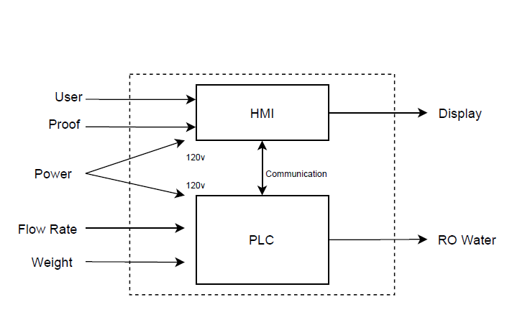

**Figure 4.2:** Level 1 Functional Decomposition

The level 1 functional decomposition (Figure 4.2) breaks the design project into two main components. The HMI and the PLC. The HMI will be everything that is on the front end that the user sees. This will include a user interface (UI), a display, and tags to differentiate what data is what coming from the PLC. The PLC will be everything that is going on in the background that the user is not seeing. This includes all the data coming from the sensors and controlling of the pumps.

* + 1. **Level 2**

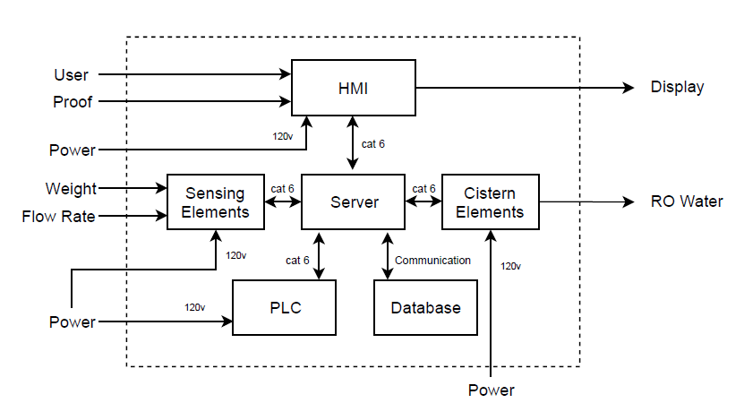

**Figure 4.3:** Level 2 Functional Decomposition

The level 2 functional decomposition (Figure 4.3) delves deeper into the PLC block of Figure 4.2. The HMI will stay the same until level 3. The PLC block is now broken down into five subsystems. The first is the server which will be communicating with every subsystem within the main PLC block. The server and database are the existing network that Bardstown Bourbon is using. The sensor subsystem takes in our two sensor inputs. The botting PLC will be the PLC directly controlling what is going on in the bottling facility. One of its takes will be controlling the bourbon dilution process. The last subsystem of this level is cistern elements which will be the pumps.

* + 1. **Level 3**

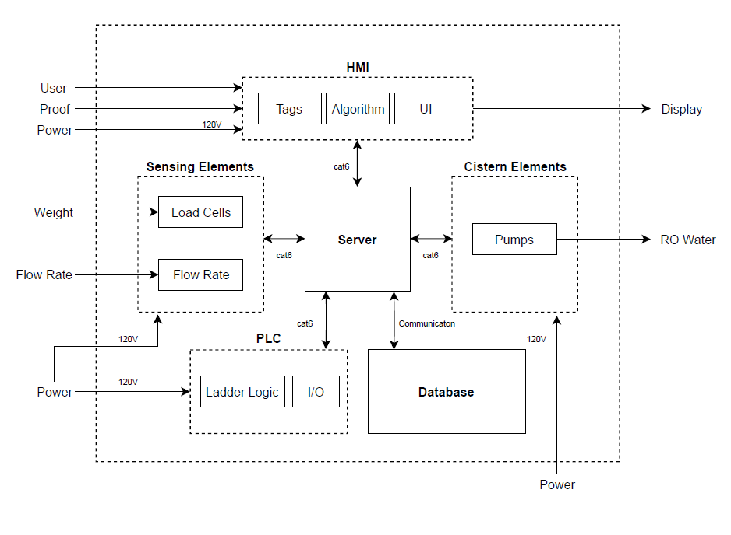

**Figure 4.4:** Level 3 Functional Decomposition

The level 3 functional decomposition (Figure 4.4) is the final and lowest decomposition in this preliminary design report. This level now breaks each of the subsystems down into items that are related to each one. The sensor subsystem now contains what sensors will be used. There will be four load cells for each cistern (one for each leg). There will be a flow rate sensor connected to the RO water holding tank that will give data on how much liquid is being pumped out of it. The bottling PLC contains addressing and ladder logic. The ladder logic is what tells the PLC what to do. It is a form of programming language for PLCs. It is a graphical language so you can trace what is happening on the screen. The input/output (I/O) of the PLC will determine how things in the system react based on input given at the HMI by the user. Certain inputs will result in a certain output on the system. The database is shown as a subsystem but this is already on site at Bardstown. Commands given at the HMI will be recorded and stored here. The cistern elements subsystem consists of the pumps. Each one of these will react to signals coming from the PLC when the user enters a command into the HMI.

* 1. **Subsystem Selection**

The control system as a whole is composed of four subsystems: HMI, Cistern Elements, PLC, and Sensing Elements.

* + 1. **Human Machine Interface (HMI)**

A Human-Machine Interface (HMI) is a user interface or dashboard that connects a person to a machine, system, or device. While the term can technically be applied to any screen that allows a user to interact with a device, HMI is commonly used in the context of an industrial process. An HMI in an industrial setting can be used to: visually display data, track production time/trends/tags, oversee key performance indicators, monitor machine inputs/outputs, and more.

The HMI that we are tasked with designing will need to achieve three main tasks. First, it must be able to send commands to the PLC and retrieve information from the database. This database will be continually updated with new information from the PLC. Second, the HMI will need to be able to display this information in an easy to read format and take user input. The user input will then be processed by the HMI and then sent as a command to the PLC once the user/system is ready. This HMI should be the connection point between the operator and the system itself. Third, it should be able to calculate and pump the correct amount of water to dilute a cistern of a known proof down to the desired proof. Overall the HMI should fit into the system as seen in Figure 4.5 below.

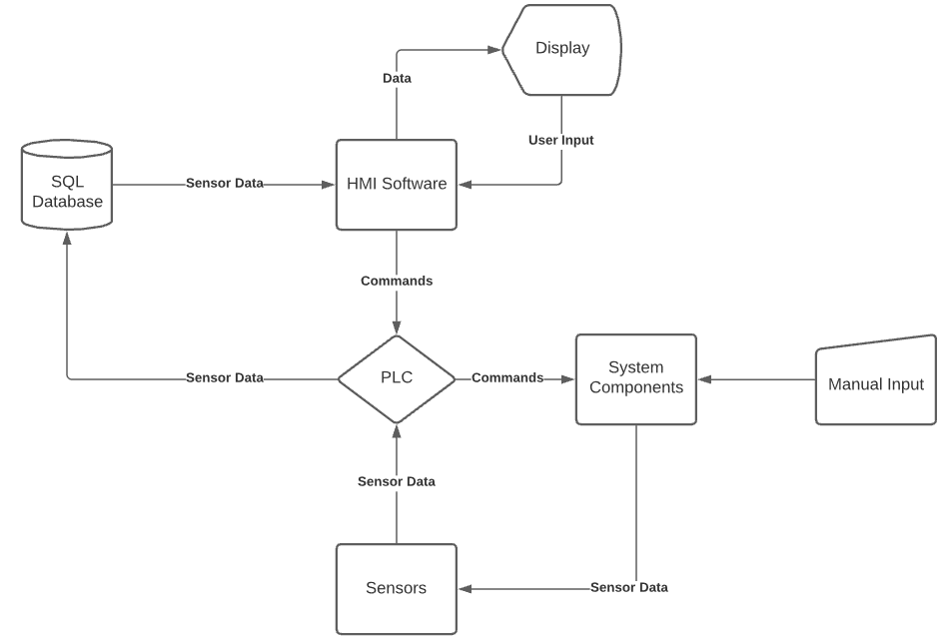

**Figure 4.5:** HMI Flow Chart

* + - 1. **Tags**

Tags are a part of the system that will help transfer information from the PLC to the HMI. These tags are variables that will hold the information in the database. They should have clear and concise names such that anyone reading them would know what they represent. This is important because they will be logged from the database for potential future reference. These tags are also going to be used when we program and design the user interface of the HMI. We will also need to make sure that we choose a good database platform for the tags. Tags are the names of all the information flowing through the system and will be the building blocks of what is displayed in the UI.

The first and most important choice that our team will have to make for the tags is what database to use. For this choice we had many different options. Some of the most common options are Oracle 12c, MySQL, Microsoft SQL Server, PostgreSQL, MongoDB, MariaDB, DB2, and SAP HANA. Some of the main factors that we need to take into consideration when choosing the database is how fast it is and how reliable it is. This is because the system will need to be updating in real time so that the operator of the HMI can see the sensor’s data as it is happening. This criteria makes MySQL the most obvious option because of a few reasons. First, this database is known for being exactly what we are looking for, fast and reliable. Second, it is free and receives updates often, which means that it should not become obsolete anytime soon. Third, it is known to work with the Ignition programming software that we will be using. All those reasons make MySQL an obvious option compared to the others, most of which we would have to pay for.

Another decision that we need to make regarding tags before we can name them is how to format them. For the format of how we write each tag’s name we have a few different options such as camel case, pascal case, snake case, kebab case, flat case, and macro case. Programming convention gives each of these a different meaning or use. For example, macro case is used to define constants, pascal case is for classes, and camel case is used for variables. With this knowledge we can then narrow down our options to those formats/cases that are used for variables. That brings us down to either camel case or snake case. Camel case being written like so, “myVarExample” and snake case being written like so, “my_var_example”. Camel case is generally more widely used, so we will choose that as our format. This will also help it be more friendly for anyone at Bardstown Bourbon to maintain our code in the future, which is one of our goals for programming the HMI.

Seen in Figure 4.6 below is a list of tags that have been created for the HMI so far. This list will grow as development continues on the HMI. These tag names are representing data coming from the PLC and the sensors connected to it.

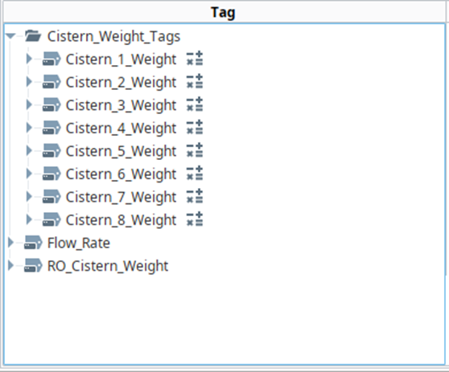

**Figure: 4.6:** Early HMI Tag List

In the figure below we can see the evolution of the tag list as we improved the HMI from the initial draft. We added tags for the selection of the cisterns, RO water calculation, and the start pump button. All the tags for the cistern selection were used for radio buttons, which you will see later in the UI section below. The RO calculation tags were used for handling the user’s input of desired proof and actual proof. They were also used for displaying the weight of RO water that our formula calculated to add.

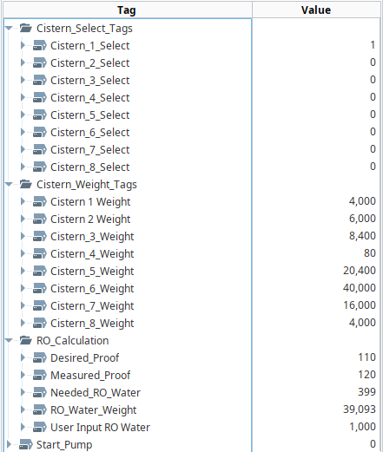

**Figure 4.7:** Final HMI Tag List

* + - 1. **User Interface (UI)**

The UI (user interface) is the means by which the user and a computer system interact, in particular the use of input devices and software. The purpose of a UI is to allow effective operation and control of a machine or multiple machines, while the machine simultaneously feeds back information that will help the operator’s decision-making process. In general, the goal of a UI is to produce an interface that is easy, efficient, and user-friendly to operate a machine in the way that produces the desired result.

The choices that we make for the design of the UI should reflect the general purpose of a UI. We will need to make choices about the layout of the data, what data we show, and how we show it. We also need to answer questions such as: should we use different screens for each cistern, should any warning messages pop up for the user, and more. As stated above, when designing the UI, it is very important to not lose sight of the goal to make it effective and user-friendly. That is the biggest goal here.

The first choice we will need to make, is regarding the layout of the screen. When looking at what we could do for this, we have two main options. First, we could design the UI to be representative of what the actual process looks like. Using pictures of cisterns, pipes, valves, etc. Second, we could design the UI to look similar to what a control panel would be like. Displaying the information in a user-friendly way with easy access to all possible inputs. Given these two options and the desired use of the HMI, it would be best if we designed the UI according to the latter of the two options. This is because the HMI should be easy to use for the operator, and all the information/inputs need to accommodate that.

Now that we have decided what the layout of the screen should generally look like, we can break it down even further. More specifically, we must now decide how to display the data. Note that this decision is difficult to boil down to a few concrete options because our options are almost limitless. Here are just a few of our possible options: we could possibly arrange everything by columns for each cistern, we could have a main screen that branches off into other screens for each cistern, or we could group like information into a single place and specify which cistern it is referring to. Given that the HMI shall be used by an operator, and they should be able to monitor the entire system at once, we can rule out the option that involves opening more screens to get to that information. However, it is important to take away a part of that idea. Specifically, the ability to focus on a single cistern at a time. This makes the option of using columns for each cistern the clear choice because all the information for a single cistern would be in one area andseparate from the others.

The final choice that we must make for the UI, is how to handle the user input. This includes where to place the input, input checking/verification, check the user is sure, and what kind of input the user can give. To figure out what kind of choices we should make here, we need to think back to what the system is supposed to accomplish. It needs to be told the proof of the bourbon in a cistern and the desired proof of that cistern. It also needs to be able to control the process of diluting the bourbon and mixing the bourbon. Also, it will need to be able to mark a cistern as complete/finished so that the next stage of the bottling process knows it is finished. The current proof and the desired proof should be added to each cistern’s column. This goes along with the decision made before about putting all a cistern’s information in a single column. Any other options do not make much sense. Next, once a current proof and desired proof have been entered the operator should be able to start the proof reduction process from the HMI for that cistern. This should not start if there is not current proof or desired proof entered for that cistern. It should also provide a double check for the operator that says something like, “Are you sure?” or, “Do you wish to continue?” Finally, once a cistern’s desired proof matches its current proof then there should be some sort of indicator and value set so that the user and system can both see this clearly. One approach would be to highlight the cistern’s column in green.

In Figure 4.8 below, we can see a rough example of what the UI will look like. The figure below is an actual example using the Ignition HMI programming software. It should display all eight cisterns and the container of RO water. They will be displayed in such a way that the HMI operator can see the status of the system at a glance. In the example below, we can easily see which cisterns are empty, full, etc. In the future this should also extend to any cisterns that are in a completed state (actual proof equals desired proof) or to any cisterns that require action (weight needing to be zeroed or proof needing to be reduced). That should allow for efficient use of the HMI. Another thing to note in the figure below is that there is plenty of empty space for us to add any other menus/controls to the UI without cluttering the screen. For example, the proof reduction menu could be placed on the left side of the screen and adjust according to whichever cistern the user wishes to look at.

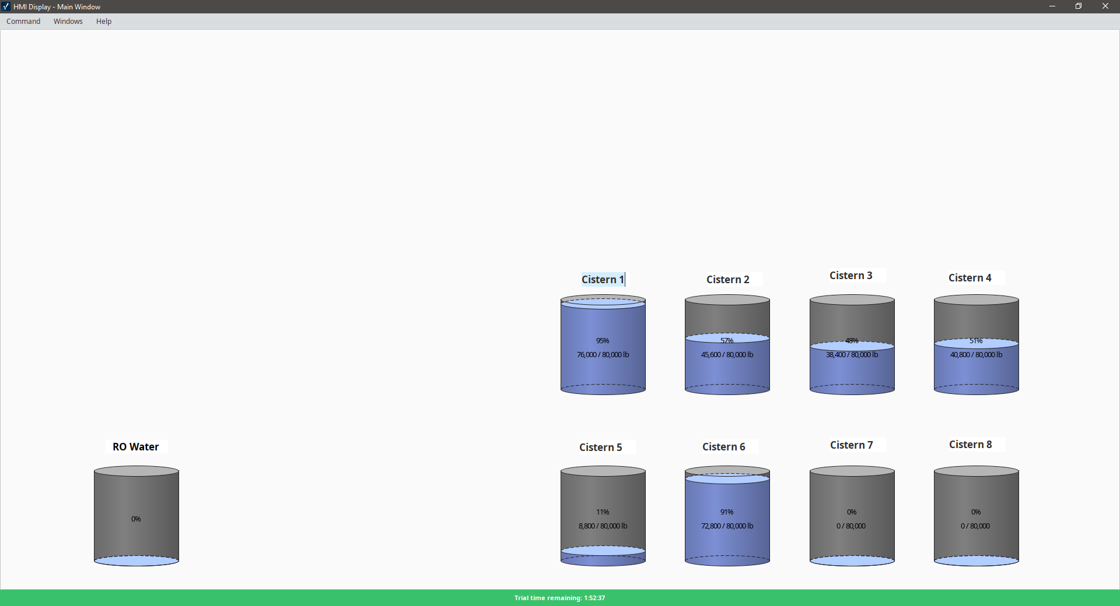

**Figure 4.8:** Early UI Progress

Once we created the outline for the initial HMI screen that you see above, we then started adding in all the components that the HMI would need to be functional. Specifically, we needed to add a way to select the cistern we wish to control, an input for the current proof of the bourbon, an input for the desired proof of the bourbon, an output for the amount of RO water that the HMI calculated to add, and a button to start the dilution process. We had initially assumed that we would need to create multiple different screens to fit everything together, but as you can see in the figure below, there was plenty of room on the screen to be able to fit everything together.

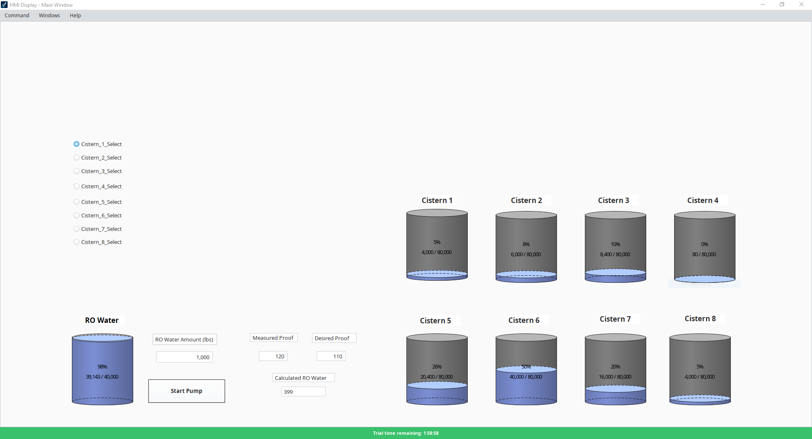

**Figure 4.9:** Final UI

Here we can see a close up of the addition for the start pump button, calculated RO water, measured proof, and desired proof. We can see that it was split into roughly three sections. The first sectio’s purpose was to display the status of the RO water tank graphically. The second section to display the weight of the RO water and a button to start the pump. The third section's purpose was to handle the input for measured proof, the input for desired proof, and the output for the calculated amount of RO water to add.

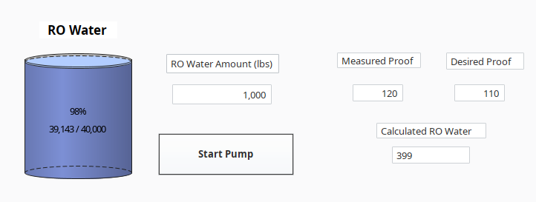

**Figure 4.10:** Inputs

Here we can see the addition to the HMI that handles the cistern selection. We decided on using radio buttons for simplicity sake. They provide an easy way to select the desired cistern with clear visible feedback as to which cistern is currently selected. This could help prevent any possible mistakes made by the user of the HMI, as they can clearly see if their selection has actually occurred upon clicking the desired cistern.

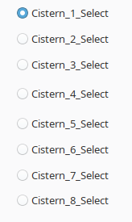

**Figure 4.11:** Cistern Selection

In the figure below we can see the final design that we decided to use for displaying the status of all the cisterns. We chose not to change anything from the initial HMI screen in order to keep things simple for the operator. As you can see in the figure below, each cistern will display the total percentage that it is filled to and the overall weight of the cistern.

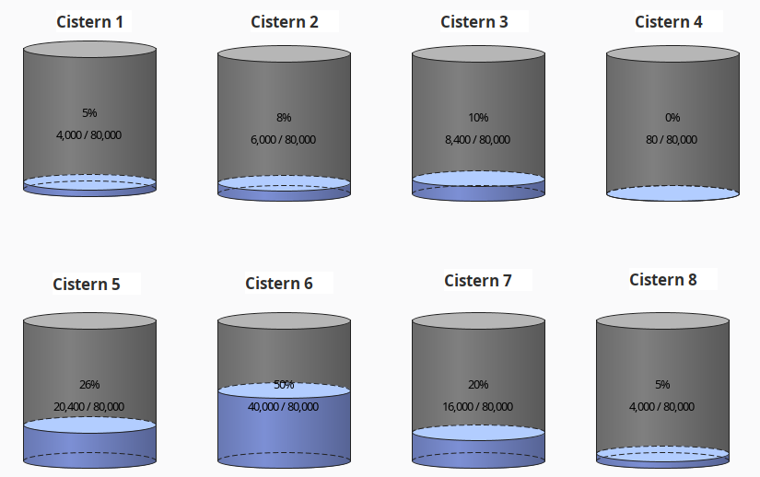

**Figure 4.12:** Cistern with load cell values

* + 1. **Control Algorithm** 
       1. **Volumetric Formula**

A control algorithm is needed for the system in order to help the system with its desired functionality: to reduce the proof of bourbon to a level that can be sold to the public, which will be set by BBC, by adding RO water to the cistern tank. This control algorithm is specifically a mathematical equation that will be implemented in the HMI Ignition software. The formula has 5 inputs: the initial weight of bourbon added to a cistern tank, the density of the bourbon, the proof of the bourbon from the barrel, the desired final proof of the bourbon and RO water mixture, and the density of RO water. The desired output is the weight in pounds of RO water that must be added to the bourbon to reduce the proof to the desired level. The steps listed below were taken to arrive to the final formula:



The first three steps show how volume can be modified into weight, which is one of the knowns of the algorithm.Step four is an equation that was found to represent how the desired proof, *Pf* , can be found mathematically, with a diluent. *Pf* is the desired proof, *VB* is the volume of bourbon, *P0* is the out-of-barrel proof of the bourbon, *VRO* is the volume of the RO water to be added.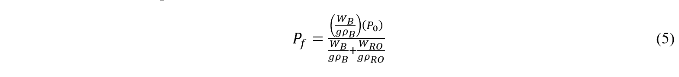In step five, the respective volumes are replaced by equation 3, with similar naming usage. For this case, since weight is in *lbs*, *g* must be *32.2 ft/s^2*, and the densities (ρ) are given in *lbs/gal*.

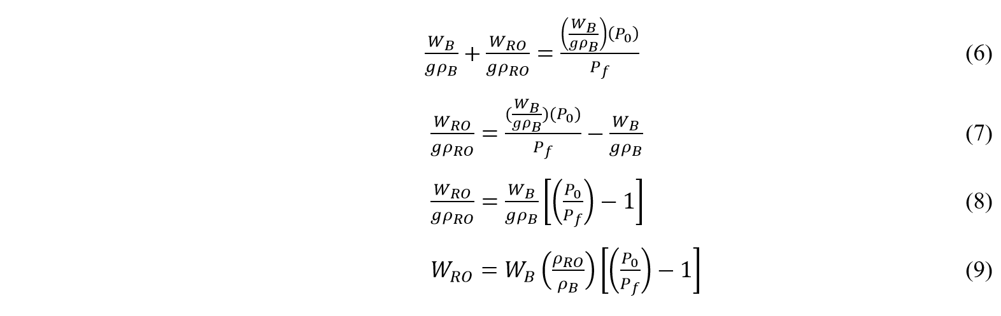Steps 6-9 are algebraic manipulations to equation 5 that result in a RO water weight that can be added to the bourbon to reach the desired proof.

* + - 1. **Tabular Method**

An alternative to using the formula previously described to find the RO water weight that needs to be added to reduce the proof of bourbon, would be to use the Alcohol and Tobacco Tax and Trade Bureau’s (TTB) tabular method. This method was formulated in 1913 and uses a table with a simple equation to find the amount of water that needs to be added to reduce the proof of a spirit. An example of a section of the table that could be useful is shown below:

**Table 4.1:** Proof to Parts Alcohol and Water [3]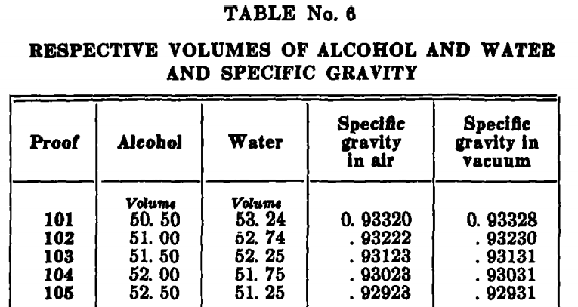

The equation given by the TTB is shown below:



In this equation, Vreq,W is the volume of water that needs to be added to the bourbon to reduce its proof to the desired level, V0,A is the volume of the alcohol at the measured proof from the table, Vf,A is the volume of the alcohol at the desired proof, Vf,W is the volume of the water at the desired proof, and V0,W is the volume of the water in the original proof. All of these volumes are per unit volumes, and represent parts. For example, at 150 proof, the spirit is 75 parts alcohol and 28.19 parts water. Thus, the units for Vreq,W is gallons of water per 100 wine gallons of spirit. Table 2 and table 3 from the TTB can then be used to convert pounds to proof gallons, from which wine gallons can be found to be proof gallons divided by proof. An example of table 2 and 3 is shown below:

**Table 4.2**: Weight, Wine Gallon, Proof Gallon Conversion [3]

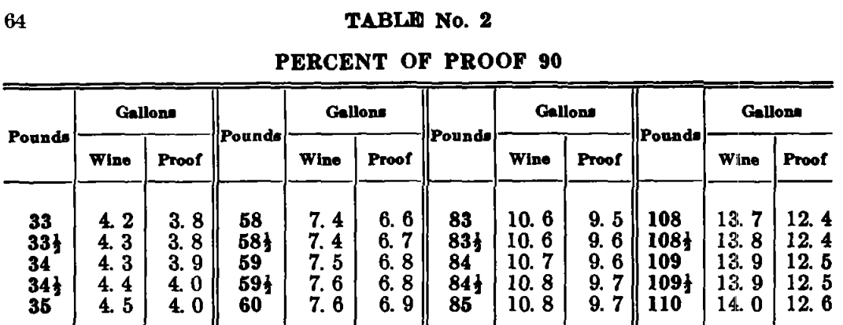

**Table 4.3:** Proof Gallons [3]

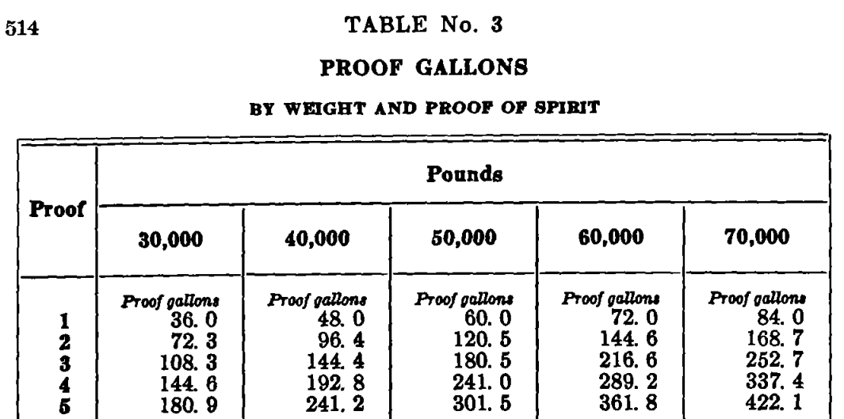

These three tables would need to then be programmed into the HMI software, Ignition with proper conversions [3].

* + - * 1. **Tabular Method Adjustments**

Upon meeting with the sponsor again, the team received some new information regarding which table from the TTB Gauging Manual that BBC uses in their process. The sponsor directed us to Table 4, not the tables suggested in the previous section. The new table is shown in Table 4.4.

**Table 4.4:** TTB Table 4 selection [3]

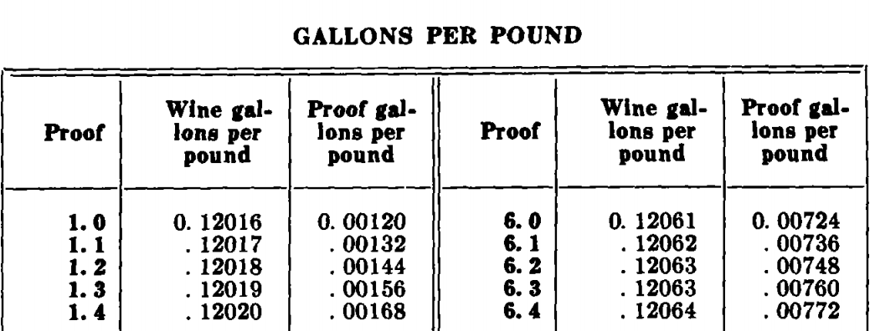

This table combines the previous tables shown in a way that provides a direct correlation between the initial proof and weight of the bourbon, as well as the desired proof. The TTB gives the following formula for using the values from the table:

$W_{RO}=(W_{B}*\frac{PG_{p0}}{PG_{dp}})-W_{B} PG_{p0}$ (11)

Where $W_{RO}$ is the weight of the RO water to be added to the mixture, $W_{B}$ initial weight of the bourbon, $PG_{p0}$ is the initial proof gallons of the bourbon from the table, and $PG_{dp}$ is the desired proof gallons of the bourbon from the table. Thus the proof gallons, which is defined as one liquid gallon of spirits that is 50% alcohol at 60 degrees F, can be pulled from the table and input into the Eqn. 11 in order to determine the amount of RO water that needs to be added to reduce the bourbon from its initial proof to the desired proof.

* + - * 1. **Conversion of PDF Table No. 4 to Excel File**

Bardstown Bourbon Company currently uses the TTB Gauging Manual Table No. 4 in order to cut its bourbon and report statistics back to the TTB. It was determined that their current method is inadequate. That is, Roger at BBC, used an exponential regression in order to predict the amount of weight needing to be added to a bourbon to reduce the proof down to the level it needs to be bottled at. In order to improve this process, the TTB Table No. 4 was converted from a PDF to an excel file that could be manipulated and used for the cutting process. Also, Roger was unaware that the Gauging manual provides a formula to be used alongside the table, this formula will be programmed into the HMI and the excel table will be used as a lookup table to input values into the formula. Figure 4.13 shows a side by side comparison of the results of the converting the PDF version of Table No. 4 into an excel file.

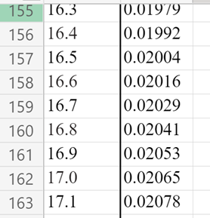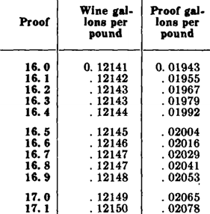

**Figure 4.13:** Conversion of PDF table to Excel

This PDF file, when downloaded as an excel file, had many errors that needed to be corrected by hand. The most common errors were missing values, a “0” appearing as an “o”, a “1” appearing as a “l”, and there was a whole section in the “161 proof” that appeared as “111 proof”. The table was also formatted so that all the values above show 5 decimal places, as it is displayed in the TTB table. Next, all the values were formatted to be numbers, so that mathematical operations can be done on them. The last step was to make sure all the values in the table matched the values displayed in the PDF. This was done by hand checking each and every value in the table, which ensures that the excel file will work in its industrial setting.

The formula that is used to convert the values from the excel sheet is displayed in Eqn. 11. This formula was pulled directly from the TTB Gauging Manual, and will help BBC improve the accuracy of their calculations for the amount of RO water needed to cut their bourbon.

As a recap, the process for using the table and formula is simple. First, the lab technician will send the initial proof of the bourbon to the HMI operator nearest to the cutting tanks. The HMI will then ask the operator to input the initial proof, and the desired proof. The HMI will then run the cutting formula code, which will go through the excel table, look up the value for the proof gallons of the initial proof and store it. It will then look up the value for the proof gallons of the desired proof and store that in another variable. Finally, the HMI will receive the value of the weight of bourbon in the cutting tank, and will use these three variables to calculate the amount of RO water that needs to be added to lower the proof. This value will then be displayed on the HMI for the HMI operator to see, and they will proceed to start the process of adding the RO water to the tank.

* + - 1. **Algorithm Conclusion**

In order to choose which design of the algorithm would be best, the criteria that must be met comes from engineering requirement number 11, which states the desired proof cannot exceed ±0.3% of the desired proof. Given this requirement, the team believes that if equation 9 can be proven to yield the desired result it would be the best selection due to its simplicity in nature. The method given by the TTB would be the most accurate, but requires a lot more time to program into the HMI. Thus, if the simple route can be chosen and proven to be effective, it will be more cost effective due to its simplicity and time it would take to program into the HMI. Otherwise, if the TTB’s method is proven to be more accurate, it should be used even though it may not be as time effective, but will be more cost effective in the future due to less calculation error.

* + - * 1. **Subsystem State**

The subsystem is in the testing phase, two tests are scheduled for the next week, and the week after.

* + - * 1. **Final Design Decision**

In order to make a final design decision for the subsystem, between the volumetric formula and the tabular method, two tests will be conducted in order to determine whether one or both of the methods meet the requirement of the proof being within ±0.3% of the displayed proof on the bottle.

The following test procedure was developed, to test the volumetric formula method:

1. Measure out ¼ lb. of bourbon, and record volume filled.
2. Calculate density of bourbon using the weight and volume of the bourbon.
3. Use the proof meter to measure and record the initial proof of bourbon.
4. Calculate amount in lbs. of RO water to add to the mixture using the density, weight, and initial proof of the bourbon.
5. Measure out the required lbs. of RO water to add to the bourbon.
6. Pour and mix RO water in with the bourbon.
7. Record the final proof of the bourbon mixture and compare it to the desired proof.

The following test procedure was developed to test the tabular method:

1. Measure out ¼ lb. of bourbon, and pour into a clean container.
2. Use the proof meter to measure and record the initial proof of bourbon.
3. Calculate amount in lbs. of RO water to add to the mixture by using the formula developed by the TTB using Table 4, to reach desired proof.
4. Measure out the required lbs. of RO water to add to the bourbon, pour and mix RO water in with the bourbon.
5. Record the final proof of the bourbon mixture and compare it to the desired proof.

Once both of these tests are completed and the results can be compared, two things will be considered when choosing which method to integrate into the system. The first thing that will need to be considered is whether or not both methods meet the TTB standard of being within ±0.3% of the displayed proof on the bottle. The second thing that needs to be considered is the run time of each of the methods. Thus, if both tests can pass the initial TTb standard, the volumetric method will be implemented because it will not require the use of a look up table (TTB Table 4), and will be able to pull real time data from the PLC devices, which will speed up the run time.

* + 1. **Automation**

The Automation subsystem consists of Pumps, Valves, and Agitators. These components are used by the Control Algorithm to automate the dilution process. The pumps send liquid into and out of the mixing cistern. The valves control where the liquid flows. The agitators mix the bourbon and reverse osmosis water ensuring a uniform product.

It is important to note that this portion of our report is no longer included in our design being delivered to our Sponsor. Our team will include this section for edification and future reference. Our Sponsor is not interested in complete automation of the bottling facility at this moment because of the cost required and their return on investment. If the new facility proves to be a financial success then our research may help their future efforts.

* + - 1. **Pumps**

There are four pumps used in this project that will be fundamentally important to the progression of fluid through the system. Operations such as transporting both the high proof alcohol and the Reverse Osmosis water into the mixing tanks will be completed using the automated pumps. The automation of the pumps will be controlled through the use of the Ignition program (HMI display), PLCs and variable frequency drives (VFD).

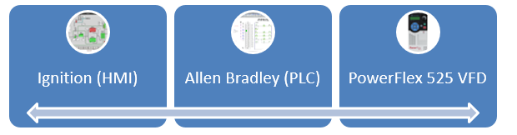

**Figure 4.14:** Pump Automation Flow

The key component that will be connected directly to the pump for automation is the VFD and will be the part that controls the activation/deactivation and speed of the pumps. The VFD that we have found best fits for the pumps and interaction with our chosen PLC’s is the PowerFlex 525 due to its integration with Allen Bradley PLCs and even has the option for Ignition based control.

The VFD controls the pump through the manipulation of input frequencies which will be determined by the logic code programmed into its module. The programmable frequency range available is 0-500 Hz and has a typical efficiency of 97.5 percent[4]. This efficiency will determine how close to the desired flow rate the pumps will operate and the 97.5 percent will prevent any underflow or overflow. These were some of the best numbers I found when searching around and was actually one of the suggested models from the sponsor.

After the high proof alcohol is placed in the filler tank the user will determine which tank to which the bourbon should go. The automation software will then activate the appropriate pump for the mixing tank and the VFD will activate the pump at the desired frequency to allow for sponsor prefered flow rate. After the tank is filled then the user can then add RO water utilizing the HMI and similar procedure as the filler tank for dilution calculations. The pumps selected for the construction of the bottling facility are seen in Figure 4.15.

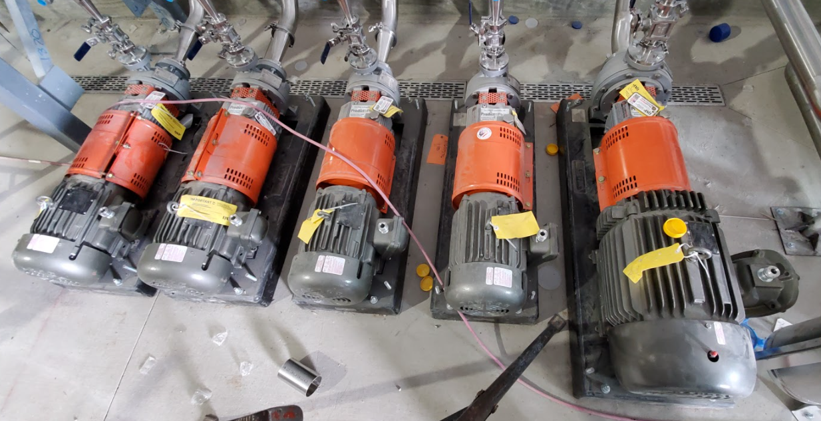

**Figure 4.15:** Pump Automation Flow

* + - 1. **Valves**

In the system immediately following the coriolis meter described in section 4.3.5.2, there are a section of 8 pipes that flow into each of the mixing tanks. For each of these tanks there will be an automated valve needed to control the direction of fluid travel. The automation of these valves will be controlled through the HMI display and the use of the PLCs. There will also be a singular setup of this for the RO water tank which will tie into the 8 pipe system following the coriolis meter.

The valves chosen from research is a cast iron solenoid valve with 2 inch fittings and the cost per valve is $227.69[5] for which 9 will be needed. This valve is normally closed which means without an input voltage the valve will not allow for fluid travel and the ratings for this valve are seen in Figure 4.4 below.

**Table 4.5:** Valve Ratings

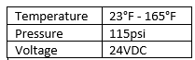

The valve solenoid will be connected to relay which in turn is connected to the PLC. When the user selects the tank for filling the PLC will close the relay allowing for 24VDC to flow into the appropriate valve transmitter causing it to open and the flow of fluids will begin. When the user is done with the filling of the tank they will unselect the filling option for the tank and the relay will open closing off the flow of fluids into the tank.

* + - 1. **Agitators**

Bourbon enters a holding cistern where its alcoholic proof is measured and used to calculate the volume of reverse osmosis water needed to dilute it to the desired proof. The process of adding RO water and measure. The measured proof must be very accurate to meet government requirements and produce a quality product. This infers the RO water must be evenly mixed, or the proof may be measured differently at different depths and locations in the cistern. For Bardstown Bourbon Company’s state-of-the-art bottling facility, the contents of the cistern are mixed with air agitators.

The agitators are an important portion of the automation subsystem because they allow for correct alcoholic proof measurements from successful mixtures. The intended agitators pump air into the bottom of the mixing tank. The air bubbles rise and push the fluid above to below it which mixes the cistern thoroughly. The selection of the agitator was not a criterion for our design but its implementation is. Our proposed design has the agitator’s operation controlled by the HMI through the PLC.

After the initial alcoholic proof is measured by either laboratory equipment or in-line proofing the results are imputed to the HMI. The automation algorithm then determines the needed reverse osmosis water needed to dilate the bourbon. The algorithm signals for the required volume of RO water and fills the tank. Then, prompts the agitator to begin mixing. The command is transferred from the HMI through the server to the PLC employing a digital signal. The PLC converts the digital signal to analog and sent to a relay. The relay closes and powers the agitator which begins functioning. The agitator stops when the algorithm, or human controller, ends the process in the HMI. The signal follows the same path to open the relay and power of the agitator.

* + 1. **Programmable Logic Controller (PLC)**

The PLC is the workhorse of industrial automation. PLCs are used to automate tasks throughout a production line. They can be used in any industry and in this case will be used to help the process of reducing the proof of bourbon. There are several things to consider when selecting a PLC to do a job. There is the brand of PLC to consider, what software package it is compatible with, and if it is capable of doing the job it will be assigned too. The inputs and outputs to the PLC must also be determined. These inputs and outputs will be the foundation for the ladder logic that must be created to determine what happens on the output when a certain input is asserted on the control system. Figure 4.16 shows the PLC control cabinet for Bardstown Bourbon Company.

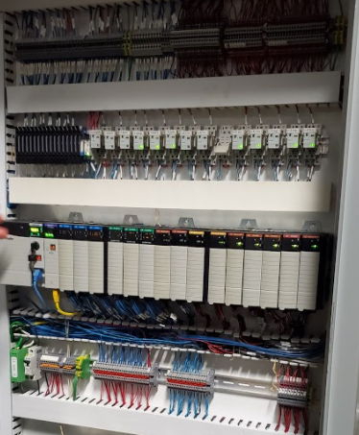

**Figure 4.16:** PLC control cabinet for BBC.

* + - 1. **Input/Output**

The inputs and outputs of the PLC are an important part of the project. The control system needs to be sent data in real time to the user at the HMI screen. This way the user can be aware of what is happening during the bourbon dilution process. An example of some inputs to an output is seen in Figure 4.17 below. This diagram shows three sensors going into the PLC as inputs. The flow rate sensor, the load cells (weight sensor) and the inline-proofing sensor. These are read into the PLC and turned into an output named data. This output can then be used by the HMI screen to display the data to the user.

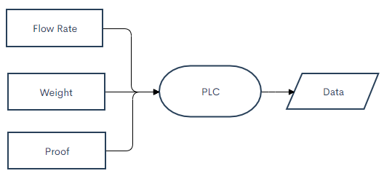

**Figure 4.17:** Sensor Inputs to Data Output

Shown in Figure 4.18 below is an example of how the data output of the PLC can be used by the HMI. The data will be displayed to the user where they can make a decision on how much RO water to add to the cistern in order to dilute the bourbon’s proof. As long as the user does not want to add RO water the program will loop continuously until the command is given. Once the command is given it will be sent to the PLC which is now an input to the PLC. The PLC will interpret what command it was given and result in an output that will turn on the pump to the RO water holding tank. This will send RO water to the desired cistern and display new data (weight of cistern) to the user as this process takes place.

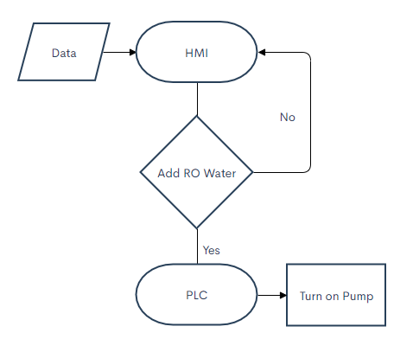

**Figure 4.18:** HMI to PLC Control of Pumps

This is a basic overview of how inputs and outputs will be used by the PLC given by either sensors or user input. To achieve what is being shown in the flowcharts a graphical programming software will need to be used. This software is called ladder logic.

* + - 1. **Ladder Logic**

As mentioned in the previous section we have inputs coming to the PLC and outputs leaving the PLC. What happens at the PLC is determined by the code that has been programmed for an arbitrary combination of inputs to an output. The PLC coding scheme that will be used on this design project is called ladder logic. Ladder logic is a graphical approach to programming a PLC and gets its name from its resemblance of an actual ladder. Let’s take a look at an example of what some ladder logic would look like. Seen below in Figure 4.19 is the standard form of what ladder logic looks like [6].

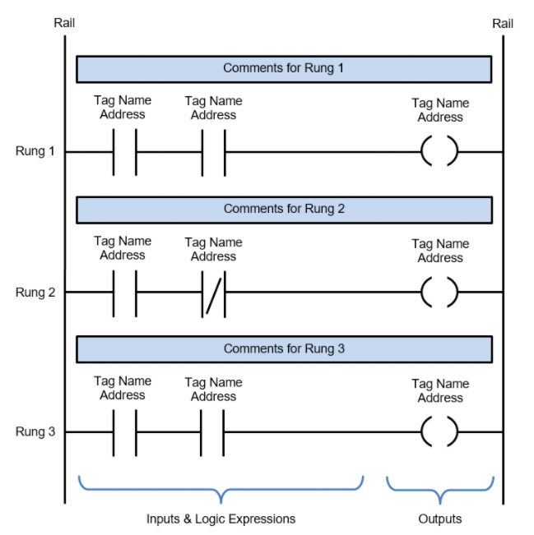

**Figure 4.19:** Ladder Logic Basics

As you can see the two rails and rungs running between them represent the ladder. It is important to note that in ladder logic the order of execution is as follows. Left to right, top to bottom. There are many parts that make up ladder logic. The rails are the sides of the ladder which represent a high side and a low side voltage level. When the logic is true for the inputs power will flow from the left (high) rail to the right (low) rail activating the output. Rungs are what the input and output logic is connected to between the high and low side rails. Inputs are devices being fed into the PLC such as a button on a HMI being pressed. Outputs are what are triggered if a rung’s logic is all true. These outputs when power is flowing can turn on motors to pumps or activate agitators. Logical expressions on the input side of the determine what inputs must be activated in order for power to flow to the output side. The tag names and addresses represent what input port the PLC is using for this tag. Finally, there is a section for comments to leave for other programmers as notes what this rung is doing in the ladder logic. This is the type of logic that will need to be developed to seamlessly connect the user at the HMI to the equipment that is used in the bourbon dilution process.

* + - 1. **Ladder Logic Tags**

The following is a table of tags that were used in the development of the ladder logic. Not every one of these tags is the same as the tags that the HMI can see. Some of them are internal to the PLC and used in doing calculations and various tasks that are happening in the background that the user cannot see happening.

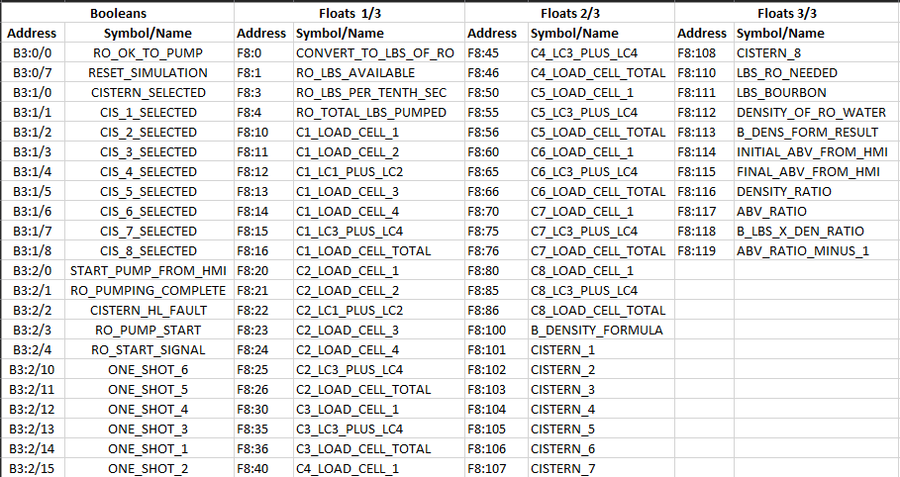

**Figure 4.20:** PLC Tag List

Figure 4:20 shown above is a list of the addresses and the symbol/name associated with that address. These are the booleans and the float addresses used in the PLC ladder logic. These are the most common types of data when programming ladder logic which is why this section is much larger than the following figure Figure 4:21 shown below which shows the inputs, outputs, and the integer values used in the ladder logic.

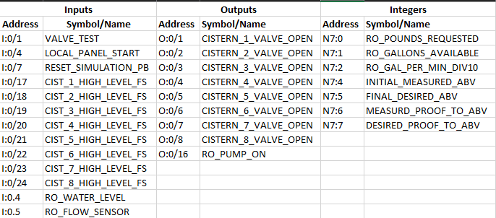

**Figure 4:21:** PLC Tag List

* + - 1. **Ladder Logic Implementation**

The ladder logic implementation was a large task to undertake. Like any large programming project it is best to break everything down into respected functions that perform a certain task and report back to the main function. This can be done in ladder logic. The main function is called the main ladder and the sub ladders are called subroutines. Ladder logic being a visual programming language it would be difficult to add screenshots of all the code as it would take up dozens of pages and the code was presented in the project demo. For the sake of the final report each ladder will be summarized on what it does starting with the main ladder.

The main ladder is constantly checking for a start signal from the HMI to start the pumping of RO water. It also contains all of the subroutine calls which are always true rungs (always scanning) for when a subroutine is needed. The RO request ladder is waiting for the request of RO water to be pumped into the selected cistern. It also keeps track of the amount of RO water available to be used.

The select cistern ladder simply determines which cistern has been selected from the HMI. The faults ladder is checking to see if there are any problems with the amount of liquid in the cisterns. This could be if there is an attempt to pump more water into a cistern than possible. The RO value ladder is using a property in ladder logic called interlocking. This means that it is only possible to pump to one cistern at a time. It is checking to make sure all the other cisterns are unselected which forms a true path for the cistern that is selected

The RO pumping ladder is in charge of keeping track of how much RO water has been pumped to the cistern. Once the amount reaches the previous cistern weight plus the weight of the newly added RO water it shuts off the pump. The RO to cistern ladder is an assistant ladder to the RO pumping ladder. It is constantly adding the weight of the newly pumped RO water to updated tags that are displaying the weight of the cisterns to the HMI. The load cells ladder is a ladder filled with all of the load cells that are used in the project that are being summed to show the total weight of each cistern.

The calculate RO pounds ladder is the subroutine that is handling the formula calculation that has been mentioned above in the formula subsystem. The last ladder is the reset simulation ladder which as it is named simply resets the values of the load cells back to their predetermined values used to demo the project to our sponsor.

* + 1. **Sensing Elements**

The Sensing Elements subsystem consists of Load Sensing Cells, a Flow Rate Sensor, and an In-line Proofing Sensor. These components transmit valuable information to the HMI through the PLC. The data collected is used by the Control Algorithm to determine future operations. All information gathered is stored in the database.

* + - 1. **Load Sensing Cells**

A load cell is a force transducer, which means that it takes the kinetic energy from a force and converts it to an electrical signal. For our project, we will be focused on the compressive force from the load weight of the cistern. We want to use the load cell to convert this compressive force into a US customary lb Weight. Before system integration, it is important to look at the types of load cells available in the industry. Three types currently exist in the industry and those are: hydraulic, pneumatic, and strain gauge.

A hydraulic load cell works by measuring the change in pressure of a liquid inside the device. The load is placed on the load cell, and the force is applied to a piston, which compresses the internal liquid, called the filling fluid, which is in a diaphragm chamber. The load cell is then able to measure the pressure change within the diaphragm chamber and this can be transmitted through a transmitter and PLC to our HMI. According to Omega, a leading manufacturer of load cells based in Pennsylvania, the hydraulic load cell does not require a power supply and is good for remote locations. The hydraulic load cell also has an accuracy within 0.25% and Omega says that it has good applications for weighing tanks. This type of load cell has ideal use in hazardous areas [7]. The graphic shown below gives an idea of the functionality of hydraulic load cell: [8]

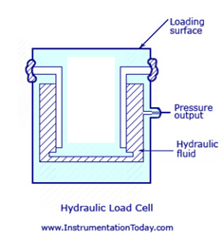

**Figure 4.22:** Hydraulic Load Cell

Another type of load cell that exists is a pneumatic load cell, and it works similarly to a hydraulic load cell and a schematic is shown below:

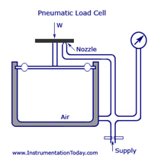

**Figure 4.23:** Pneumatic Load Cell

A difference between pneumatic and hydraulic is that the pneumatic load cells have multiple dampener chambers, which leads to an increase in accuracy. A dampener chamber acts in a similar way to the diaphragm chamber, but it essentially is a separator and separates the air flow. Thus, the pressure inside of the load cell will change, given the input air supply to balance the load, and a measurement can be taken from there. According to Omega, pneumatic load cells are good for small weight, to be used in industries where cleanliness and safety is a primary concern, and are insensitive to temperature [7].

The final and most common type of load cell on the market is a strain gauge load cell. The strain gauge load cell operates as shown in the schematic below:

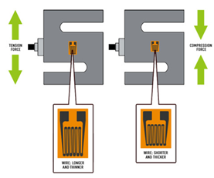

**Figure 4.24:** Strain Gauge Load Cell

Essentially, a strain gauge load cell works by measuring the electrical resistance developed by a force, which has a resistance, and is then converted to a voltage from which the weight can be calculated. One step further, when the load cell undergoes tension the wire becomes longer and thicker which correlates to an increase in resistance. When a compressive force is applied the wire becomes shorter and thicker, which correlates to a decrease in resistance. Finally, to increase the accuracy, a Wheatstone bridge must be used to link multiple strain gauge load cells together and is shown below:[9]

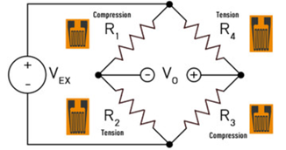

**Figure 4.25:** Wheatstone Bridge Strain Gauge

Now that these three categories have been presented. There are a few subcategories of load cells, and the two types to be considered for the system are canister and pancake load cells, because they are industry standard for large capacity load such as tank loading and truck measurements. According to ATO, a pancake load is called a low profile load cell because it is small in stature and looks like a pancake. The pancake load cell is able to handle both tension and compression loads, and is widely used for platform scale, truck scale, rail weighbridge and tension tester [10]. The other type of load cell that was considered was a canister load cell, which Central Carolina Scale says are the best choice for high capacity weighing. They come in a variety of different capacities and they are typically used in vehicle weighing, and tank and hopper weighing applications. Canister load cells are hermetically sealed, which means that they offer protection against potentially hazardous environments. There are two types of canister load cells, compression and tension. Compression canister load cells are typically used in tank and hopper applications and operate similarly to the strain gauge load cell shown above, thus they are a great choice for the system [11].

**Table: 4.6:** Load Cell Comparison

|  |  |  |  |
| --- | --- | --- | --- |
| Load Cell Comparison | | | |
| Option 1: | ATO: ATO-LC-P02[12] | | |
| Features   * Cost: $240.20 * Operating Temperature: -20℃ to 65℃ * Accuracy: 0.05 % F.S * Capacity: 20,000 lb * Safety Overload: 150% F.S * Cable Length: 6m * Transmitter, Junction box needed * Pancake load cell, Strain gauge | | |
|
| Option 2: | Load Cell Central: SPWE-CA-20K[13] | | |
| Features:   * Operating Temperature: -12℃ to 43℃ * Accuracy: 0.18 % F.S * Capacity: 20,000 lb * Safety Overload: 150% F.S * Cable Length: 7.5m * Adapter Conduit * Pancake Load Cell, Pneumatic * Cost: $1,205.00 * Transmitter, Junction box needed | | |
|
| Option 3: | Coti Global Sensors: CG-21 20k[14] | | |
| Features:   * Cost: $1,512.50 * Operating Temperature: -10℃ to 40℃ * Accuracy: 0.18 % F.S * Capacity: 20,000 lb * Safety Overload: 150% F.S * Cable Length: 15.24m * Canister load cell, Strain gauge * Cannot be bolted down * Transmitter, Junction box needed | | |
|
| Option 4: | Futek: LCF500[15] | | |
| Features   * Operating Temperature: -51.11℃ to 71.1℃ * Capacity: 20,000 lb * Safety Overload: 150% F.S * Pancake Load Cell * Cost: $5,300.00 * Cable Length: Not included * Accuracy: 0.32 % F.S * Pancake load cell, Strain gauge * Transmitter, Junction box needed | | |
|
| Option 5: | Omega: LCHD-20K[16] | | |
| Features:   * Operating Temperature: 16℃ to 71℃ * Capacity: 20,000 lb * Safety Overload: 150% F.S * Pancake Load Cell, strain gauge * Cost: $1,293.00 * Cable Length: Cable not included * Accuracy: 0.21 % F.S * Transmitter, Junction box needed | | |
|

**Table 4.7:** Load Cell AHP

|  |  |  |  |  |  |  |
| --- | --- | --- | --- | --- | --- | --- |
|  | **Weight** | **ATO** | **LCC** | **Coti** | **Futex** | **Omega** |
| **Accuracy** | 0.27 | 0.11 | 0.29 | 0.29 | 0.13 | 0.17 |
| **Cost** | 0.15 | 0.32 | 0.24 | 0.14 | 0.11 | 0.19 |
| **Op. Temp.** | 0.08 | 0.19 | 0.14 | 0.11 | 0.24 | 0.32 |
| **Capacity** | 0.43 | 0.23 | 0.23 | 0.23 | 0.23 | 0.23 |
| **Cable** | 0.02 | 0.19 | 0.14 | 0.32 | 0.11 | 0.11 |
| **Safety** | 0.05 | 0.23 | 0.23 | 0.23 | 0.23 | 0.23 |
| **Total Points** | | 0.26 | 0.29 | 0.28 | 0.23 | 0.26 |

As seen above in Table 4.7, the best sensor choice is Load Cell Central’s SPWE-CA 20k due to its high accuracy, average cost. This load cell will fit nicely into the system and given the description, a transmitter and junction box will be necessary. Given that the specifications for operating temperature fit within the project description, and the cable is included with a good length, this would be a great choice for the system.

Load Cell Central does sell their own transmitter and junction box, and therefore it is unnecessary to find another for the system implementation. A load cell transmitter is an electrical device that sends readings from the load cell to the PLC [17]. A junction box is an electrical device that combines multiple load cell inputs and can then be connected to the transmitter [18]. These devices are essential to successful operation of the load cells and are required for the system. The installed load cells at the bottling facility is seen in Figure 4.26.

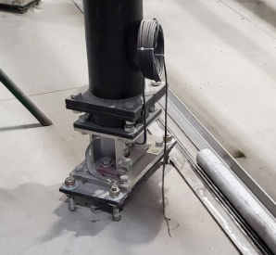

**Figure 4.26:** Installed load cell at the BBC bottling facility.

* + - 1. **Flow Rate Sensor**

Our proposed control algorithm uses the density of the bourbon being processed to calculate the volume of reverse osmosis water required to dilute it. A deeper insight into our dilution calculation can be found in section 4.3.1.3. above. Our team discussed and concluded the best way for our HMI to access the bourbon density was through a sensor. The amount of liquid flowing into the system is also very useful information to prevent an overfill of the cistern. Seemingly, our team was going to select and implement two separate sensors: one for density and one for flow rate. It was then discovered that select flow rate sensors are capable of measuring both. Our preliminary design is to implement a single flow rate sensor, connected to a PLC and interfaced with the HMI.

According to the Analog Design Journal article "Industrial flow meters/flow transmitters", the four most common flow rate meters used in industrial applications are differential pressure, electromagnetic, ultrasonic, and Coriolis. Differential pressure meters use the difference in pressure across a constriction to measure flow velocity [17]. These are easily maintained but are inaccurate at low pressure. Electromagnetic meters use the electric voltage through a fluid induced by a magnetic field to calculate the flow rate. This sensor only works with conductive liquids. Ultrasonic meters use the interaction of sound and fluid to measure the flow rate. The sensor requires extensive knowledge of the liquids flow profile. These sensors do not meet our criteria because the bourbon is flowing at low pressure, the conductivity of bourbon is unknown and RO water is not conductive, and bourbon's flow profile changes with each batch and barrel.

The Coriolis meter, however, has the liquid flow through a tube that vibrates at a resonant frequency [17]. The vibration in the tube is transferred to the flowing liquid and causes the tube to twist. Electrodes at each end of the tube measure the phase difference of the twisting, which has a direct relationship with mass flow. Coriolis meters do not measure the volume of liquid flowing but the mass of the liquid flowing. These meters are also capable of measuring the density of the liquid because the oscillating frequency is dependent on the liquid's density [17]. These factors make it an obvious option for our proposed design.

There are two components required to implement a Coriolis flow rate meter: the sensor and transmitter. There are multiple different brands of meters (many are only compatible with their brand of sensors and transmitters). Notable brands include E+H, Bronkhorst, and Emerson. These brands have multiple makes and models for different applications. Research led us to compare one meter from each of these three manufacturers. Table 4.8, shown below, compares the benefits and disadvantages of these alternative meters.

**Table 4.8:** Comparison of Coriolis Flow Rate Meters

|  |  |  |  |
| --- | --- | --- | --- |
| Coriolis Flow Rate Meter Comparison | | | |
| Option 1: | Bronkhorst mini CORI-FLOW M14 [18] | | |
| Pros:   * Fast Response Time (< 200 ms). * Measures density, temperature, and mass flow. * Compatible with PLC with provided cabling. * Built in transmitter. | Cons:   * Low accuracy:   + Density: ± 5 kg/m3   + Mass flow: ± 0.2% * Is only compatible with 1/2” piping and smaller. | |
|
| Option 2: | E+H Proline Promass Q 500 Coriolis Flowmeter [19] | | |
| Pros:   * Compatible with 1-4” pipes. * Measures Mass flow, temperature, and density. * High Accuracy:   + Density: ± 0.2 kg/m3   + Mass flow: ± 0.05% | Cons:   * Requires transmitter to be compatible with PLC. * High Cost (Requires quote for pricing). | |
|
| **Option 3:** | Emerson Micro Motion ELITE CMF200M Coriolis Meter [20] | | |
| Pros:   * Compatible with a variety of standard pipe sizes. * Measures Mass flow, density, temperature, volume flow, and volume. * High Accuracy:   + Density: ± 0.2 kg/m3   + Mass flow: ±0.05% | Cons:   * Requires purchase of separate transmitter (Micro Motion 5700 Field-Mount Transmitter). * High Cost (Requires quote for pricing). | |
|

Our selected Coriolis flow sensor is the Emerson Micro Motion ELITE CMF200M Coriolis Meter with the Emerson Micro Motion 5700 Field-Mount Transmitter. This sensor and transmitter combination is very suited for our needs. It is PLC compatible, has low error bounds, and works with the two-inch piping infrastructure of the bottling system. The Bronkhorst meter has low accuracy and is only compatible with ½” pipes or smaller. These factors alone make it not suited for our design. The E+H Proline Promass Q 500 Coriolis flowmeter is our design alternative. It has similar accuracy to the Emerson but does not measure as many quantities. The Emerson meter measures mass flow rate, density, and temperature along with volume flow rate and volume. Mass flow rate must be converted to volume flow rate for the total volume flowing through the meter to be found. The Emerson meter was selected over the E+H because it does not require this conversion, thus is easier to implement. The selected Coriolis installed at the new BBC bottling facility is seen in Figure 4.27.

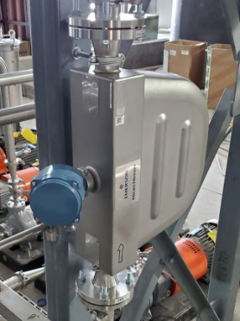

**Figure 4.27:** Coriolis flow rate meter installed at the BBC bottling facility.

* + - 1. **In-line Proofing Sensor**

The following section was researched and suggested in order to further automate the process of cutting bourbon to the correct proof. After presenting this to Bardstown Bourbon, they have chosen to not pursue this solution at the moment. The reasoning for this is that in-line proofing is very expensive. Bardstown Bourbon did not want to pay up front for this design. They would like to wait and determine the profits from the new facility. However, this design may be useful in the future given that a return on investment is within reason.

Due to TTB standards, alcohol that is to be distributed must maintain a 0.3% tolerance. In order to achieve this, samples must be extracted from the tank and taken next door to a laboratory. Once into the lab, the sample is tested using old school methods. If the 0.3% tolerance isn’t yet met, Bardstown Bourbon will then add more reverse osmosis water and uncut bourbon until the required tolerance is met. This works, but our proposal is a way to automate this process.

In order for a solution to be viable, it must be compatible with PLC and HMI configurations. It should also be able to make measurements based on density because that is currently what BBC uses to determine proof of the alcohol. This should also be a cost effective solution, which also takes into consideration maintenance costs as well as cost of installation.

The proposal is to implement inline-proofing. After researching different solutions, the only device that meets TTB standards is an inline alcohol monitor made by Anton Paar. Specifically the Anton Paar L-Dens 7500 configuration. This device utilizes digital signal processing to output the density and contains its own transmitter, the Pico 3000 to communicate with the PLC. It comes with its own HMI as well which would also be very convenient. [21] Table 4.9, seen below, shows what can be achieved as well as some operating specifications.

**Table 4.9:** Technical Specification of In-line Alcohol Monitor [21]

|  |  |
| --- | --- |
|  | **L-Dens 7500** |
| **Process Density** | Max 2000 kg/m^3 |
| **Accuracy in Adjusted Range** | 0.01 kg/m^3 |
| **Process Temperature** | -40 degrees C to 125 degrees C |
| **Dimensions** | 190mm x 160mm x 205mm |

The solution must also be rated to withstand explosions due to the high proof of the alcohol and electrical components. The L-Dens 7500 does have an explosion-proof version but requires a slipstream implementation of the piping. This slip-stream would be a sort of recirculation line in which the sensor can be installed, utilizing the flow of the liquid to determine the proof.

There are no operating costs or wearing parts which makes this one time installation a smart option. The L-Dens 7500 utilizes Davis 5, which is a data acquisition and visualization software. This allows the user to save all data and alarms. It provides statistical process control with graphical trend analysis. [22] This allows for adjustments when necessary and the device can be password-protected to provide additional security. If the device is compatible with Davis 5, then it should also be compatible with Ignition because they essentially do the same thing. More research will need to be done to determine a final say in this.

1. **Design Integration, Verification, and Validation**

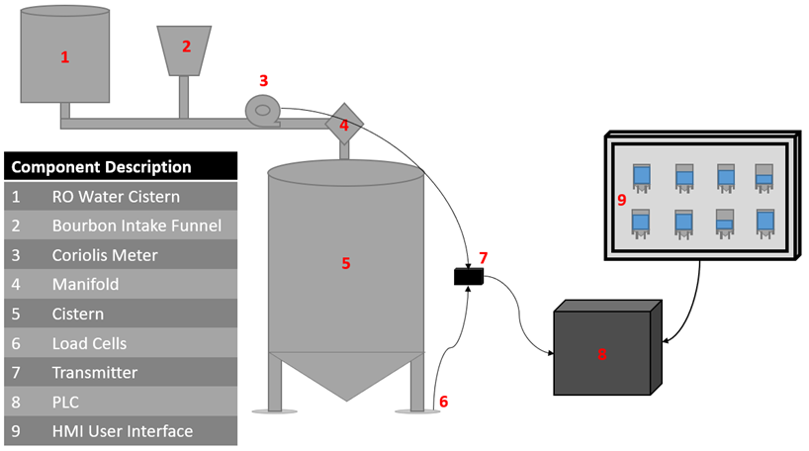

**Figure 5.1:** Design Overview Diagram

Figure 5.1 shows a big picture overview of the project's design. The RO water is stored in location 1 and the bourbon enters the system through the Bourbon intake labeled 2. The fluid flows through the Coriolis meter listed 3. The cistern location of the fluid is selected by the manifold listed 4. There are 8 different mixing cisterns listed 5 and each cistern has four load cells listed 6. These along with the Coriolis meter are connected to a transmitter listed 7 and that is connected to the PLC listed 8. The PLC is directly interfaced with the HMI listed 9.

The image mentioned is a simplified model of our design. Bourbon enters the dilution system through the bourbon intake funnel and piped through the Coriolis Meter and the piping manifold into one of the 8 cisterns. This is where the flow rate and density is measured. The proof of alcohol is measured and recorded into the HMI by means of a lab sample. The control algorithm uses this along with the desired proof and weight of the cistern to determine how much RO water needs to be added. The Coriolis Meter and the load cells send their data through their transmitter which converts to a signal the PLC can understand. The PLC then sends all the information to the HMI. The operator uses the user interface of the HMI to record the desired proof and send commands to other users and components on the system.

**5.1 HMI/PLC Testing**

Regarding the testing of the HMI and PLC we will focus on the following few areas:

1. Testing the connection of the HMI to the database.
   1. Specifically that the HMI is able to populate it’s screen based off of the tags found in the database.
2. Testing incorrect/erroneous user input into the HMI.
   1. The HMI should check that the user’s input is not a string/character.
   2. The HMI should check that the user’s input is not something absurd. We know that we will mostly be dealing with numbers in a certain range, and therefore we should display warnings for any numbers not in that range.
3. Testing each control screen and its behavior in accordance with our logic.
   1. The proof reduction process
   2. The zero cistern weight process
4. Testing that the HMI is able to connect and send commands to the PLC.
   1. This can be done very simply by sending a command and from the HMI and having someone monitor the PLC to see if the command is received. This does not include checking to see if the PLC responds to the command properly, as that should be a part of the PLC testing.
5. It would also prove beneficial to get feedback about the UI from a third party.
   1. From our sponsors to see if they have any requested changes for how the UI works.
   2. From someone who works in a qualified field related to UI design or someone who uses HMIs.

**5.2 Control Algorithm Testing**

All of the hand calculations for this section are presented in Appendix B.

The control algorithm was tested to prove that the volumetric formula could yield the similar results as the tabular method. A seven step process was developed in order to test the volumetric formula and is outlined in this section.

1. Calibrate proof meter and verify that tap water comes out to 0 proof.
2. Calculate the density of water.
3. Measure the proof of the spirit.
4. Calculate the density of the spirit.
5. Use the volumetric formula to determine how much water needs to be added for dilution.
6. Add water to the spirit, and stir.
7. Add the mixture to a graduated cylinder, measure the proof, and compare to the expected result.

Step 1: This step is the first step because in order for the experiment to be successful, the water being added to the spirit must be non-alcoholic. Note, the volumetric formula assumes that proof of the liquid being added has a proof of 0, this formula would not work for mixed alcohols because the proof of the alcohol being added would need to be considered. Figure 5.2, shows that the tap water that was used for this experiment did in fact meet the requirement of being 0 proof.

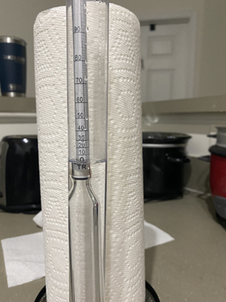

**Figure 5.2:** Proof of Water

The device used in this image is called a proof meter, the way it works is by using density to find the proof of the liquid. The proof meter was dropped in the water, and after bobbing stopped, the meniscus of the water leveled out at 0 proof, which was expected.

Step 2: Per the volumetric formula in Eqn. 9, the density of the water is required in order to find the amount of RO Water to be added. This step was completed using the chemistry principle of density being the total mass divided by the total volume. Thus, a measuring cup was used because it can hold a specific volume of liquid, and can be placed on a scale to give an accurate weight. The scale that was used for this experiment displayed the most significant figures when set in an oz. unit setting. The measuring cup weighed approximately 12.2 oz. which is equal to 0.7625 lbs. To get an accurate density, 1 cup of water was added to the measuring cup, and weighed 1 lb., 4.1 oz., which is equal to 1.25625 lbs.. Therefore, the weight of the water added is found by subtracting the measuring cup weight from the total weight, which was 0.49375 lbs.. The density was then computed by dividing the water weight by 1 cup of volume, which is equal to 0.23658 L, and the density was found to be 2.087 lbs/L. This matches the expected value for water, which is 2.2 lbs/L.

Step 3: This step was done, also because it is a required value for the volumetric formula. The proof of the spirit was measured the same way as in step 1, with a small difference. For this step, the proof meter was stuck directly into the bottle in order to ensure a big enough sample size, for accuracy.

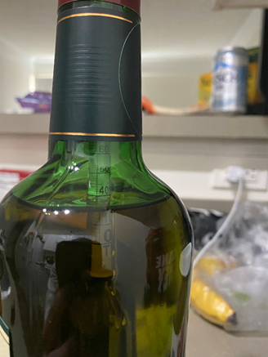

**Figure 5.3:** Proof of alcohol in bottle

From Figure 5.3, the meniscus of the spirit can be seen resting at 40, in this figure, the 40 represents 40% alcohol or 80 proof. This is what was expected as the spirit label presents the alcohol as being 80 proof.

Step 4: This step was also necessary for the volumetric formula to be used, and was done in a similar manner to step 2. A different measuring cup was used for this step, so that there would be no mixing of water and spirit before step 6. This measuring cup had a weight of 0.8875 lbs., and 75mL of spirit was added to the measuring cup, and the total weight of spirit and cup was 1.01875 lbs. Thus, the weight of spirit was calculated to be 0.13125 lbs., and the density of the spirit was found to be 1.75 lbs/L. Although, each spirit is going to be different, this value is acceptable because the density is less than water, which is expected of a spirit.

Step 5: This step is one of the main functionalities of the experiment, and is the base for proving that the experiment is accurate. The chosen dilution proof for this experiment was chosen to be 60 proof, to allow for enough water to be added in order to visually see a difference, with the given tools. Thus, when the weight of the spirit, the 2 densities, and the 2 proofs are plugged into the volumetric formula, a result of 0.052175 lbs. or 0.8348 oz. was yielded. Note that it would be sufficient to stop here and take the same values and use the tabular method and compare the results, to determine whether or not the volumetric formula is accurate; this will be explained in section 5.2.1.

Step 6: This step was completed in order to make sure that the mixture did not contain any pockets of just spirit or just water. This was done to ensure that the experiment was accurate, because if the two liquids are not mixed properly, the experiment could yield a different result than expected.

Step 7: This step was done to prove that the volumetric formula is indeed accurate. This experiment would be best done with a graduated cylinder, but it was improvised by using the packaging of the proof meter because it is similarly shaped. The proof meter, in order to work, needs to be suspended in the liquid, which requires a tall container. Thus, the packaging of the proof meter was substituted for the graduated cylinder. After adding the mixture to the container, the proof was measured to be around 60 proof, which is the desired result.

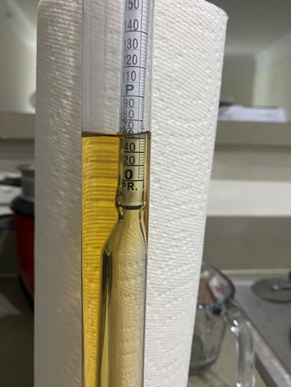

**Figure 5.4:** Proof Meter

From Figure 5.4, it can be shown that the meniscus of the mixture lies at 60 proof, which means that it can be concluded that the volumetric formula does indeed work as it is supposed to.

**5.2.1 Comparison of Volumetric Formula and Tabular Method**

The second verification of the volumetric formula was to compare the value found for the amount of RO water to be added to the value that would be yielded using the tabular method. This was done by using the same value as in the volumetric formula experiment, for the weight of the spirit, and the initial and desired proofs. Thus, the tabular method was used to compute a value of RO water to be added to the spirit, and was found to be 0.046253 lbs., which differs from the value found in the volumetric formula experiment by 0.00592 lbs. Therefore, it can be concluded that the volumetric formula would be accurate if used on an industrial scale, because household tools were used to compute the value in the volumetric formula experiment. When implemented in an industrial setting, industrial level tools will be used, and the accuracy of the volumetric formula will be improved.

1. **Project Plan**

The following three sections are a breakdown of the process that will go into the development and implementation. They include the Work Breakdown, Gantt Chart, Cost Analysis, and Team Member Responsibilities. Each of these breakdowns are integral in the completion of this design project. These will allow us to stay on task and view what needs to be done. It will also allow us to see who is responsible for each task that needs to be completed for the project.

* 1. **Work Breakdown**

The following table is a work breakdown of each subsystem in the project. The breakdown includes the activity that needs to be completed in order for us to complete the design project.

**Table 6.1:** Work Breakdown

|  |  |  |  |  |  |  |  |
| --- | --- | --- | --- | --- | --- | --- | --- |
|  | | | | | | | |
| 1 | **Human Machine Interface** | | | | | | |
| **ID** | **Activity** | **Description** | **Deliverable** | **Duration (days)** | **Team Members (s)** | **Resources** | **Predecessors** |
| 1.1 | Create Tags | Assign a tag name to all data coming from the PLC to the database | Working tags that can be used to display data coming from the PLC | 3 | Mitch  Seth | Software manual, Inductive university training |  |
| 1.2 | Create Weight Icons | Design or pick the icon we wish to use in the HMI to represent the weight | An icon for the weight data | 1 | Matt  Josh | Software manual, Inductive university training | 1.1 |
| 1.3 | Create Flow Rate Icon | Design or pick the icon we wish to use in the HMI to represent the flow rate | An icon for the flow rate data | 1 | Matt  Josh | Software manual, Inductive university training | 1.1 |
| 1.4 | Create Cistern Icons | Design or pick the icon we wish to use in the HMI to represent the cisterns | An icon for the cistern | 1 | Matt  Josh | Software manual, Inductive university training | 1.1 |
| 1.5 | Create Proof Percentage Icon | Design or pick the icon we wish to use in the HMI to represent the proof percentage | An icon for the proof percentage data | 1 | Matt  Josh | Software manual, Inductive university training | 1.1 |
| 1.6 | Create RO Water Icon | Design or pick the icon we wish to use in the HMI to represent the RO water | An icon for the RO water | 1 | Matt  Josh | Software manual, Inductive university training | 1.1 |
| 1.7 | Create UI | Design the layout of the UI. Display the data from the PLC and take input from the operator | A UI screen capable of displaying real time data and taking input | 7 | Matt  Josh | Software manual, Inductive university training | 1.1,1.2,1.3,1.4,1.5 |
| 2 | **Programmable Logic Controller** | | | | | | |
| **ID** | **Activity** | **Description** | **Deliverable** | **Duration (days)** | **Team Members (s)** | **Resources** | **Predecessors** |
| 2.1 | Connect inputs and outputs to PLC | Physically connect cables to the PLC | Data coming from sensors and signals leaving PLC | 7 | Mitch  Seth  Craig | Hardware schematics, wiring diagrams |  |
| 2.2 | Develop Ladder Logic for combination of inputs and tasks to perform | Create ladder logic to control flow of processes in bourbon dilution | Working set of input action resulting in an output | 28 | Mitch  Seth  Craig | Tutorials, Guidance from sponsor, software manual | 2.1 |
| 3 | **Formula and Lookup Table** | | | | | | |
| **ID** | **Activity** | **Description** | **Deliverable** | **Duration (days)** | **Team Members (s)** | **Resources** | **Predecessors** |
| 3.1 | Create Lookup Table | Convert a word document of a table into an excel document | Excel document | 14 | Craig, Trevor, | Excel |  |
| 3.2 | Test Formula | Test a formula derived to reduce the proof of bourbon | Working formula | 7 | Everyone | Research documents |  |
| 4 | **Sensing Elements** | | | | | | |
| **ID** | **Activity** | **Description** | **Deliverable** | **Duration (days)** | **Team Members (s)** | **Resources** | **Predecessors** |
| 4.1 | Coriolis flow rate meter and load cells communicate with the HMI. | The Coriolis meter and load cells need to correctly transmit their recorded data though the PLC and to the HMI. | Correct sensor data being displayed to the HMI | 7 | Josh, Seth | Installation guide, wiring diagram |  |

* 1. **Gantt Chart**

In order to keep the team on track to complete the project by May 14th, 2021, the team has developed the Gantt chart shown below. The purpose of the Gantt chart is to give a graphical timeline that shows when certain parts of the project should be completed in order to remain on schedule to meet the deadline. The Gantt chart is broken down into 11 parts: parts 1 and 2 deal with reports that are due by the end of the semester November 24th, 2020; part 3 gives a timeline for the construction of the bottling facility at BBC; part 4 is senior design day (presentation of 1st semester work); part 5 is the HMI software training that each member must complete before the beginning of the spring semester January 26th, 2021; parts 6 through 9 are detailed layouts of each subsystem design that needs to be completed before the final systems integration; part 10 is the final testing of the system integration to ensure proper functionality; and part 11 is the end of the semester senior design presentation of the final system success. All of the dates presented below are relative and likely to change given different demands from BBC, as this is a rough outline the team came up with given the information we have from the instructor team and the sponsor BBC.

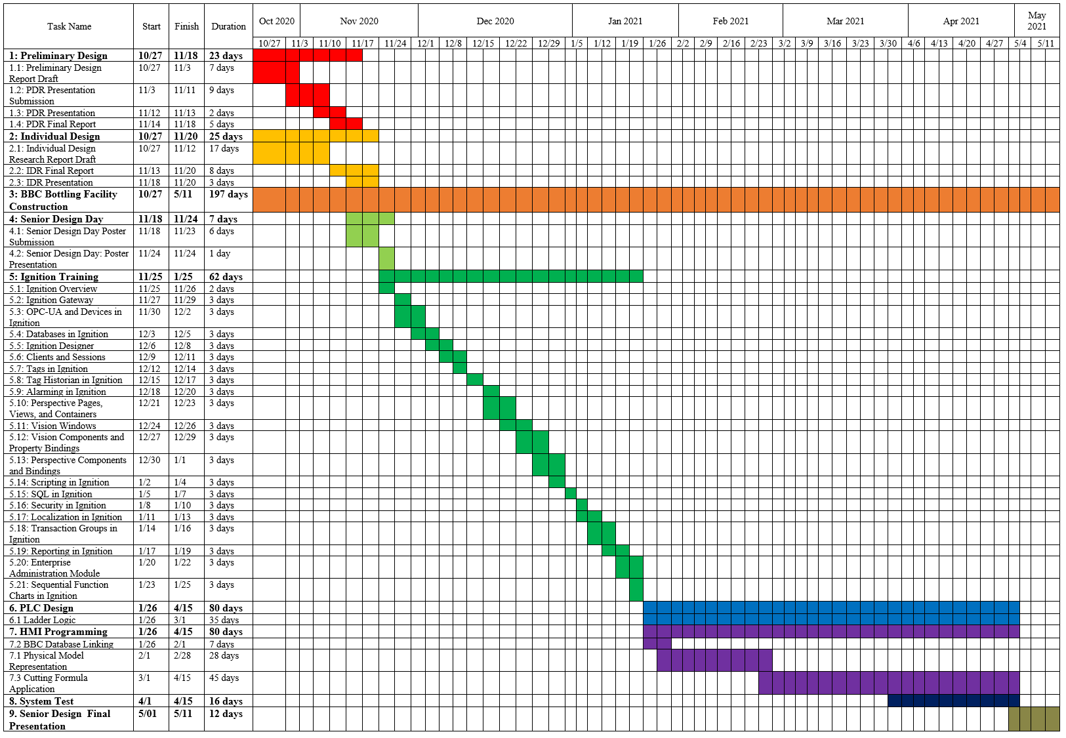

**Figure 6.1:** Overall Gantt Chart

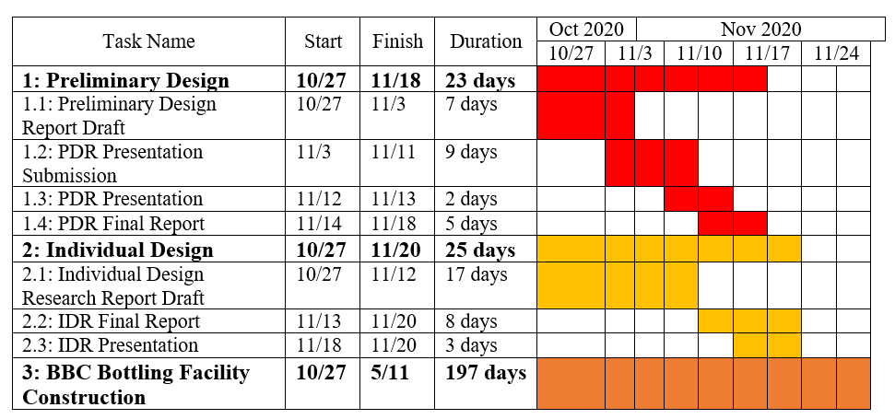

**Figure 6.2:** Zoomed in Gantt Chart 1

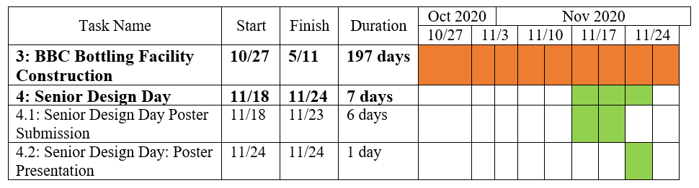

**Figure 6.3:** Zoomed in Gantt Chart 2

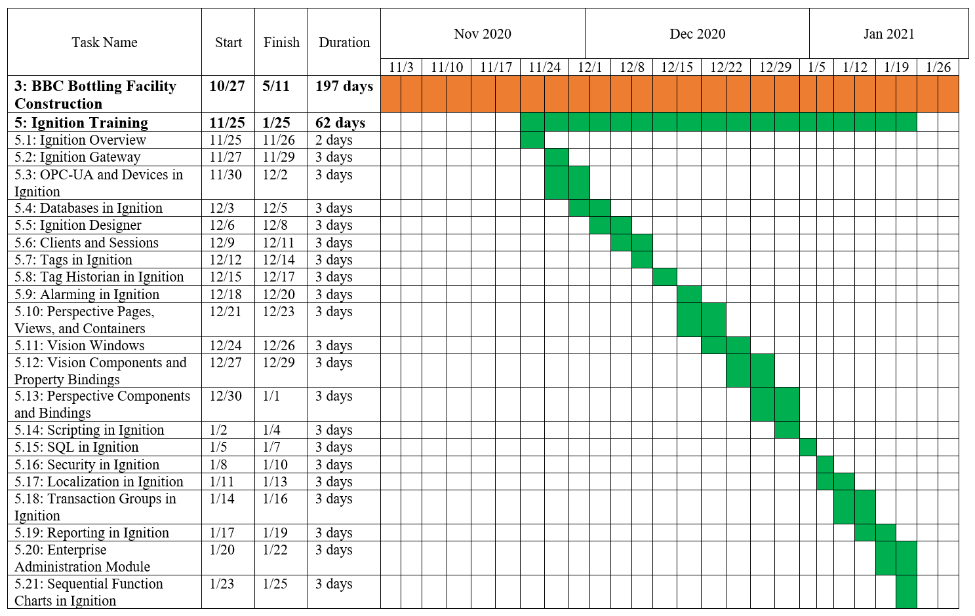

**Figure 6.4:** Zoomed in Gantt Chart 3

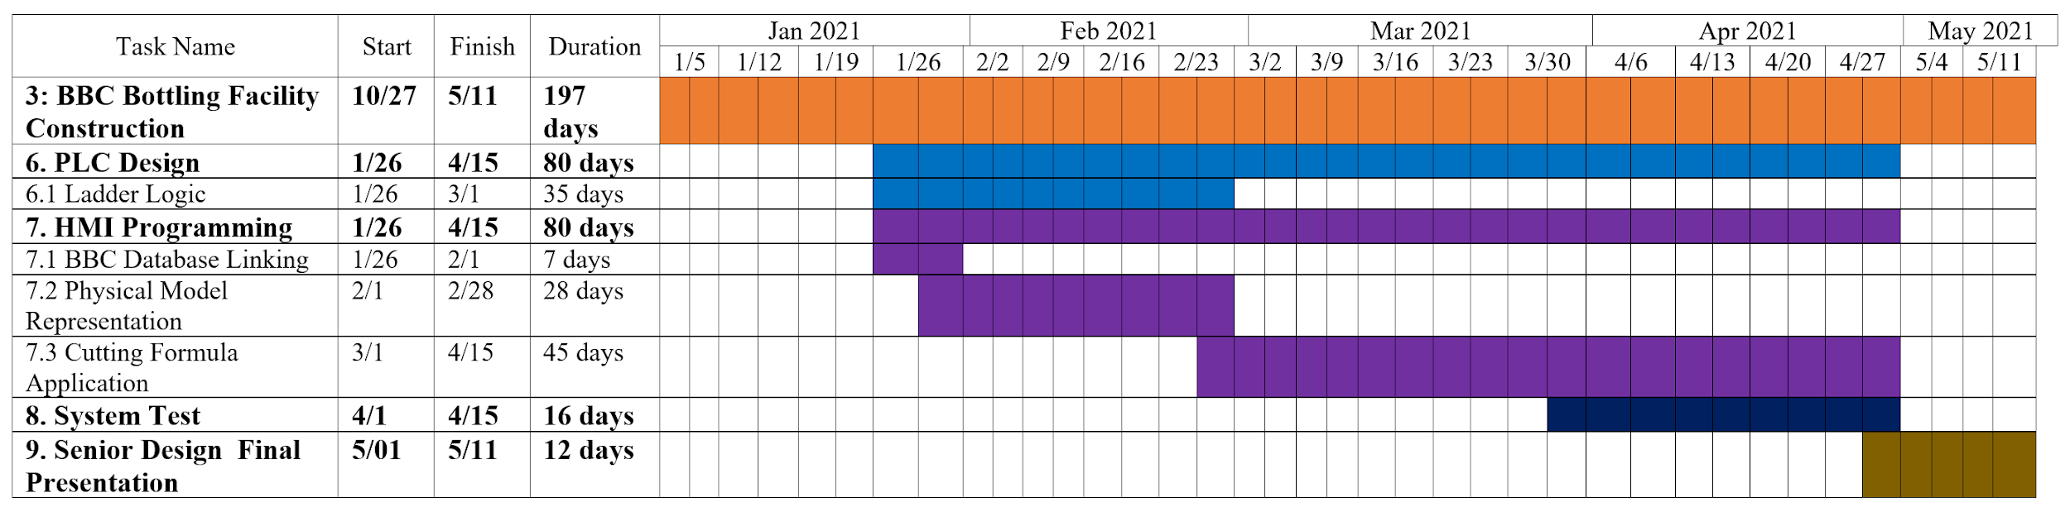

**Figure 6.5:** Zoomed in Gantt Chart 4

* 1. **Cost Analysis**

**Table 6.2:** Cost Analysis

|  |  |  |  |  |
| --- | --- | --- | --- | --- |
| **Device** | **Manufacturer** | **Item** | **Quantity** | **Cost** |
| ~~Alcohol Monitor~~ | ~~Anton Paar~~ | ~~L-Dens 7500~~ | ~~1 @ $15000~~ | ~~$15,000.00~~ |
| Load Cell | Load Cell Central | SPWE-CA-20K | 32 @ $1205 | $38,560.00 |
| Junction Box | Load Cell Central | S4J1 | 8 | Waiting on quote |
| Transmitter | Load Cell Central | TLM8ETHERCAT | 1 @ $785 | $785.00 |
| ~~Variable Frequency Drive~~ | ~~Allen Bradley~~ | ~~PowerFlex 525~~ | ~~5~~ | ~~Waiting on quote~~ |
| Coriolis Flow Rate Sensor | Emerson | Micro Motion ELITE CMF200M Coriolis Meter | 1 | Waiting on quote |
| Coriolis Flow Rate Transmitter | Emerson | Micro Motion 5700 Field-Mount Transmitter | 1 | Waiting on quote |
| ~~Solenoid valve~~ | ~~PRMFiltration~~ | ~~SV200DFD50NO24VDCVX~~ | ~~9 @ $227.69~~ | ~~$2049.21~~ |
|  |  | Total: | 43 pieces | $39,345 |

* 1. **Team Member Responsibilities**

This project has been divided into four subsystems that each have several subsections. The subsystems are: Human Machine Interface, Automation, Programmable Logic Controller, and Sensing Elements. These are discussed deeper in Subsystem Selection, section 4.2. Table 6.3, seen below, offers a breakdown of each team member’s individual contribution during the design phase of the first semester. Table 6.4, also seen below, offers a breakdown of each team member’s individual contribution during the building phase of the second semester. The table offers a list of names, subsystem, subsection, and a brief description of their work.

**Table 6.3** A breakdown of each team member’s responsibilities during the design phase.

|  |  |  |
| --- | --- | --- |
| **Bourbon Dilution System** | | |
| **Human Machine Interface (HMI):** | | |
| Name: | Subtask: | Description: |
| Matthew Walker | Tags | Create tags for the HMI that represent data coming from the PLC. These tags can then be used to create a variety of icons and symbols. These icons and symbols will be the building blocks for the UI of the HMI. |
| Matthew Walker | User Interface (UI) | Design a UI that is capable of displaying relevant data and information. The UI should be capable of accepting commands and inputs from the operator. |
| Trevor Veenstra | Control Algorithm | Design an algorithm for the control of the dilution system. The algorithm is to use the sensor and user inputs to calculate and manage the next operation of the system. |
| **Automation:** | | |
| Name: | Subtask: | Description: |
| Craig Tate | Pumps | Research and propose automated pump systems that can push/pull bourbon and RO water into/out of the holding cisterns. The pumps are to be operated by the control algorithm in the HMI through a PLC. |
| Craig Tate | Valves | Research and propose valves that can be opened and closed by the HMI through a PLC. The valves allow or suppress the flow of bourbon and RO water in and out of a holding cistern. |
| Joshua McCarty | Agitators | Research possible methods and machines that can evenly mix the contents of a holding tank. They are to be controlled from the HMI through a PLC. |
| **Programmable Logic Controller (PLC):** | | |
| Name: | Subtask: | Description: |
| Mitchell Maddix | Ladder Logic | Research and understand how a PLC is programmed and controlled. Create the logic for correct outputs when commands are entered on the HMI. |
| Mitchell Maddix | Input / Output | Determine what are the inputs to the PLC and how ladder logic should be applied to obtain the correct outputs. |
| **Sensing Elements:** | | |
| Name: | Subtask: | Description: |
| Trevor Veenstra | Load Sensing Cells | Research, select, and implement a sensor to accurately measure the weight of the liquid in a holding cistern. The weight is to be sent to the HMI through the PLC. |
| Joshua McCarty | Flow Rate Sensor | Research, select, and implement a sensor to accurately measure the density, volume, and flow rate of the liquid being pumped into a holding cistern. The data is to be recorded and displayed in the HMI through the PLC. |
| Seth Damron | In-line Proofing Sensor | Research, select, and implement a sensor to accurately measure the alcoholic proof of the bourbon being pumped into a holding cistern. The sensor must transmit its data through the PLC to the HMI. |

**Table 6.4** A breakdown of each team member’s responsibilities during the building phase.

|  |  |  |
| --- | --- | --- |
| **Bourbon Dilution System** | | |
| **Human Machine Interface (HMI):** | | |
| Name: | Subtask: | Description: |
| Matthew Walker | Tags | Create tags for the HMI that represent data coming from the PLC. These tags can then be used to create a variety of icons and symbols. These icons and symbols will be the building blocks for the UI of the HMI. |
| Joshua McCarty | User Interface (UI) | Design a UI that can display relevant data and information. The UI should be capable of accepting commands and inputs from the operator. |
| Trevor Veenstra &  Craig Tate | Control Algorithm | Design an algorithm for the control of the dilution system. The algorithm is to use the sensor and user inputs to calculate and manage the next operation of the system. |
| **Programmable Logic Controller (PLC):** | | |
| Name: | Subtask: | Description: |
| Seth Damron | Ladder Logic | Research and understand how a PLC is programmed and controlled. Create the logic for correct outputs when commands are entered on the HMI. |
| Mitchell Maddix | Input / Output | Determine what are the inputs to the PLC and how ladder logic should be applied to obtain the correct outputs. |

1. **References**

[1] “Bourbon Facts - Kentucky Distillers Association”, Kentucky Distillers Association. [Online]. Available: https://kybourbon.com/bourbon_culture-2/key_bourbon_facts/. [Accessed 27 September 2020].

[2] M. Fort, “How to calculate percentage of alcohol content in cocktails?,” *Conscious Mixology*, 19-Mar-2017. [Online]. Available: http://www.consciousmixology.com/how-to-calculate-percentage-of-alcohol-content-in-cocktails/. [Accessed: 04-Nov-2020].

[3] T. Bugher, “TTB: Gauging Manual,” TTBGov - Distilled Spirits. [Online]. Available: https://www.ttb.gov/foia/distilled-spirits-gauging-manual. [Accessed: 04-Nov-2020].

[4] Literature.rockwellautomation.com. 2020. [online] Available at: <https://literature.rockwellautomation.com/idc/groups/literature/documents/td/520-td001_-en-e.pdf> [Accessed 4 November 2020].

[5] PRM Filtration. 2020. *Solenoid Valve, 2 Inch Cast Iron, 24 VDC, Normally Closed, Flanged Connection With Viton Seals*. [online] Available at: <https://shop.prmfiltration.com/collections/cast-iron-solenoid-valves/products/cast-iron-solenoid-valves-24vdc-normally-closed-flanged-with-viton-seals> [Accessed 4 November 2020].

[6] “Ladder Logic Basics”, Ladder Logic World. [Online]. Available: “https://ladderlogicworld.com/ladder-logic-basics/. [Accessed 11 November 2020].

[7] “OMEGA Engineering,” Omega Engineering. [Online]. Available: https://www.omega.co.uk/prodinfo/load-cells.html. [Accessed: 04-Nov-2020].

[8] P. by John, “Search for ‘load cell’ - Instrumentation-Electronics,” Instrumentation. [Online]. Available: http://www.instrumentationtoday.com/?s=load+cell. [Accessed: 04-Nov-2020].

[9] D. Trent and With Load Cell Central since 2017, “Strain Gauge Load Cell Basics,” How Does a Strain Gauge Load Cell Work? | Load Cell Central. [Online]. Available: https://www.800loadcel.com/load-cell-and-strain-gauge-basics.html. [Accessed: 04-Nov-2020].

[10] “What is a Pancake Load Cell?,” ATO. [Online]. Available: https://www.ato.com/what-is-a-pancake-load-cell. [Accessed: 04-Nov-2020].

[11] “Load Cells - Canister,” Canister Load Cells | Compression, Tension, High Capacity. [Online]. Available: https://www.centralcarolinascale.com/Compression-Canister.htm. [Accessed: 04-Nov-2020].

[12] “Tension/Compression Load Cell, Low Profile, 500kg/30 ton to 100 ton,” ATO.com. [Online]. Available: https://www.ato.com/compression-load-cell-low-profile-200kg-to-100-ton. [Accessed: 04-Nov-2020].

[13] “Model SPWE: Low-Profile Vessel Weighing Load Cell,” Low-Profile Vessel Weighing Load Cell | Tank and Hopper Scales | Load Cell Central. [Online]. Available: https://www.800loadcel.com/load-cells/pancake-shear-web-load-cells/spwe.html. [Accessed: 04-Nov-2020].

[14] “CG-21,” Coti Global. [Online]. Available: https://www.cotiglobal.com/cg-21/. [Accessed: 04-Nov-2020].

[15] “Universal Pancake Load Cell,” *Universal Pancake Load Cell LCF500 : QSH01956*. [Online]. Available: https://www.futek.com/store/load-cells/universal-pancake-load-cells/universal-pancake-LCF500/QSH01956. [Accessed: 18-Nov-2020].

[16] “Omega Engineering,” *Ultra Low Profile, Tension and Compression Load Cells*. [Online]. Available: https://www.omega.com/en-us/force-strain-measurement/load-cells/lchd/p/LCHD-20K. [Accessed: 18-Nov-2020].

[17] “Load Cell Junction Box Signal Trim,” *Load Cell Junction Box Signal Trim | Load Cell Central*. [Online]. Available: https://www.800loadcel.com/load-cell-hardware/j-boxes.html. [Accessed: 18-Nov-2020].

[18] “Model TLM8 Load Cell Transmitter,” *Load cell transmitter with analog, digital, and relay outputs. Ethernet & fieldbus options available. | Load Cell Central*. [Online]. Available: https://www.800loadcel.com/electronics/signal-conditioners/tlm8.html. [Accessed: 18-Nov-2020].

[19] D. Kalyanaraman, “Industrial flow meters/flow transmitters,” Analog Applications Journal, no. 2Q, pp. 28–32, 2012.

[20] *Bronkhorst*. [Online]. Available: https://www.bronkhorst.com/en-us/products-en/liquid-flow/mini-cori-flow/m14/. [Accessed: 03-Nov-2020].

[21] *Endress+Hauser*. [Online]. Available: https://portal.endress.com/wa001/dla/5001121/0154/000/06/TI01287DEN_0719.pdf. [Accessed: 03-Nov-2020].

[22] *Emerson*. [Online]. Available: https://www.emerson.com/en-us/catalog/micro-motion-sku-cmf200m?fetchFacets=true#facet:&partsFacet:&facetLimit:&productBeginIndex:0&partsBeginIndex:0&orderBy:&partsOrderBy:&pageView:list&minPrice:&maxPrice:&pageSize:&. [Accessed: 03-Nov-2020].

[23] “Inline density meter: L‑Dens 7000 series,” *Anton Paar*. [Online]. Available: https://www.anton-paar.com/us-en/products/details/l-dens-7000-density-sensor-series/?ref=adwords. [Accessed: 17-Nov-2020].

[24] Software, E. and 5, D., 2020. *Data Recording Software: DAVIS 5 :: Anton-Paar.Com*. [online] Anton Paar. Available at: <https://www.anton-paar.com/us-en/products/details/davis-5-software-for-the-recording-storing-visualization-and-analysis-of-measured-data/> [Accessed 4 November 2020].

1. **Appendix A**

To find the weights for the first level of the objective tree, the decision matrix is shown below in Table 1A.

**Table 1A:** AHP Matrix for the top level of the Objective tree.

|  |  |  |  |  |  |
| --- | --- | --- | --- | --- | --- |
|  | **Software** | **Data Reception** | **Functional** | **User Compatible** | **Weights** |
| **Software** | **1** | **1/7** | **1/7** | **1/3** | **0.06** |
| **Data Reception** | **7** | **1** | **1** | **3** | **0.40** |
| **Functional** | **7** | **`1** | **1** | **3** | **0.40** |
| **User Compatible** | **3** | **1/3** | **1/3** | **1** | **0.14** |

The team used a scale of 1, 3, 5, 7 to determine the significance of each of the categories. A 1 was treated as of equal importance, a 3 was treated as more important, a 5 was treated as much more important, and a 7 was treated as most important. Thus, a fraction would be the reciprocal or opposite of the significance. From there, weights were found by calculating the geometric mean of each row, and dividing it by the sum of the geometric means. The equation for geometric mean is in equation 1, which is shown below:

Geometric mean = $\sqrt[n]{x_{1}*x_{2}*... *x_{n}}$ (1)

The results of the table show that equal weight is to be placed on data receiving and functionality, when making design decisions for the HMI, while less weight is to be placed on user compatibility, and the least amount of weight is to be placed on the software used.

For the second level of the tree a decision matrix was not used for the software, data reception, and user compatible categories because there are only two branches for each of these categories.

It was decided by the team that the Ignition software and Studio 5000 software had to receive equal weights because one cannot work without the other. In other words, Studio 5000 is directly connected to Ignition, and therefore the two leaves received equal weights because one is necessary for the other.

It was decided that hardwired connection and database storage should receive equal weight under the data reception category, because each is equally important to the process. Without a hardwired connection, the database would be useless, and without the database, the hardwired connection would have nothing to transmit data to.

It was decided that user input capability was more desirable than a user friendly display for the user compatible category, and thus it received a higher weight. A weight of 0.7 was chosen on the basis that user input capability is much more important than user friendly display, and thus a heavier weight was given.

Finally, a decision matrix was used for the functional category and followed the same principles as in the decision matrix used for the first level. The results are shown below

**Table 2A:** AHP Matrix for the first level of the Objective tree.

|  |  |  |  |  |
| --- | --- | --- | --- | --- |
|  | **RO Water Weight Calculations** | **Cistern Hardware Control** | **Weight Sensor** | **Weights** |
| **RO Water Weight Calculations** | **1** | **1/3** | **1/5** | **0.10** |
| **Cistern Hardware Control** | **3** | **1** | **1/3** | **0.26** |
| **Weight Sensor** | **5** | **3** | **1** | **0.64** |

The results of the table show that the most weight is to be placed on the weight sensor, when making design decisions, while less weight is to be placed on cistern hardware control, and the least amount of weight is to be placed on the RO water weight calculations.

The following tables are used to compare each load cell option against the others for each of the 6 decision categories regarding the selection of the load cells. These tables feed the values in Table x. For the AHP process a 1 was given if the option was less than the other for the given category, a 3 was given if the values were the same for the given category, and a 5 was given if the option was greater than the other for the given category.

**Table 3A:** Load Cell Accuracy AHP Matrix

|  |  |  |  |  |  |  |
| --- | --- | --- | --- | --- | --- | --- |
| Accuracy | **Option 1** | **Option 2** | **Option 3** | **Option 4** | **Option 5** | **Weight** |
| **Option 1** | 3 | 1 | 1 | 1 | 1 | 0.11 |
| **Option 2** | 5 | 3 | 3 | 5 | 5 | 0.29 |
| **Option 3** | 5 | 3 | 3 | 5 | 5 | 0.29 |
| **Option 4** | 3 | 1 | 1 | 3 | 1 | 0.13 |
| **Option 5** | 3 | 1 | 1 | 5 | 3 | 0.17 |

**Table 4A:** Load Cell Cost AHP Matrix

|  |  |  |  |  |  |  |
| --- | --- | --- | --- | --- | --- | --- |
| Cost | **Option 1** | **Option 2** | **Option 3** | **Option 4** | **Option 5** | **Weight** |
| **Option 1** | 3 | 5 | 5 | 5 | 5 | 0.32 |
| **Option 2** | 1 | 3 | 5 | 5 | 5 | 0.24 |
| **Option 3** | 1 | 1 | 3 | 5 | 1 | 0.14 |
| **Option 4** | 1 | 1 | 1 | 3 | 1 | 0.11 |
| **Option 5** | 1 | 1 | 5 | 5 | 3 | 0.19 |

**Table 5A:** Operating Temperature AHP MAtrix

|  |  |  |  |  |  |  |
| --- | --- | --- | --- | --- | --- | --- |
| Op. Temp. | **Option 1** | **Option 2** | **Option 3** | **Option 4** | **Option 5** | **Weight** |
| **Option 1** | 3 | 5 | 5 | 1 | 1 | 0.19 |
| **Option 2** | 1 | 3 | 5 | 1 | 1 | 0.14 |
| **Option 3** | 1 | 1 | 3 | 1 | 1 | 0.11 |
| **Option 4** | 5 | 5 | 5 | 3 | 1 | 0.24 |
| **Option 5** | 5 | 5 | 5 | 5 | 3 | 0.32 |

**Table 6A:** Capacity AHP Matrix

|  |  |  |  |  |  |  |
| --- | --- | --- | --- | --- | --- | --- |
| Capacity | **Option 1** | **Option 2** | **Option 3** | **Option 4** | **Option 5** | **Weight** |
| **Option 1** | 3 | 3 | 3 | 3 | 3 | 0.23 |
| **Option 2** | 3 | 3 | 3 | 3 | 3 | 0.23 |
| **Option 3** | 3 | 3 | 3 | 3 | 3 | 0.23 |
| **Option 4** | 3 | 3 | 3 | 3 | 3 | 0.23 |
| **Option 5** | 3 | 3 | 3 | 3 | 3 | 0.23 |

**Table 7A:** Load Cell Cable Length AHP Matrix

|  |  |  |  |  |  |  |
| --- | --- | --- | --- | --- | --- | --- |
| Cable | **Option 1** | **Option 2** | **Option 3** | **Option 4** | **Option 5** | **Weight** |
| **Option 1** | 3 | 1 | 1 | 5 | 5 | 0.19 |
| **Option 2** | 5 | 3 | 1 | 1 | 1 | 0.14 |
| **Option 3** | 5 | 5 | 3 | 5 | 5 | 0.32 |
| **Option 4** | 1 | 1 | 1 | 3 | 1 | 0.11 |
| **Option 5** | 1 | 1 | 1 | 1 | 3 | 0.11 |

**Table 8A:** Load Cell Capacity AHP Matrix

|  |  |  |  |  |  |  |
| --- | --- | --- | --- | --- | --- | --- |
| Capacity | **Option 1** | **Option 2** | **Option 3** | **Option 4** | **Option 5** | **Weight** |
| **Option 1** | 3 | 3 | 3 | 3 | 3 | 0.23 |
| **Option 2** | 3 | 3 | 3 | 3 | 3 | 0.23 |
| **Option 3** | 3 | 3 | 3 | 3 | 3 | 0.23 |
| **Option 4** | 3 | 3 | 3 | 3 | 3 | 0.23 |
| **Option 5** | 3 | 3 | 3 | 3 | 3 | 0.23 |

**9. Appendix B**

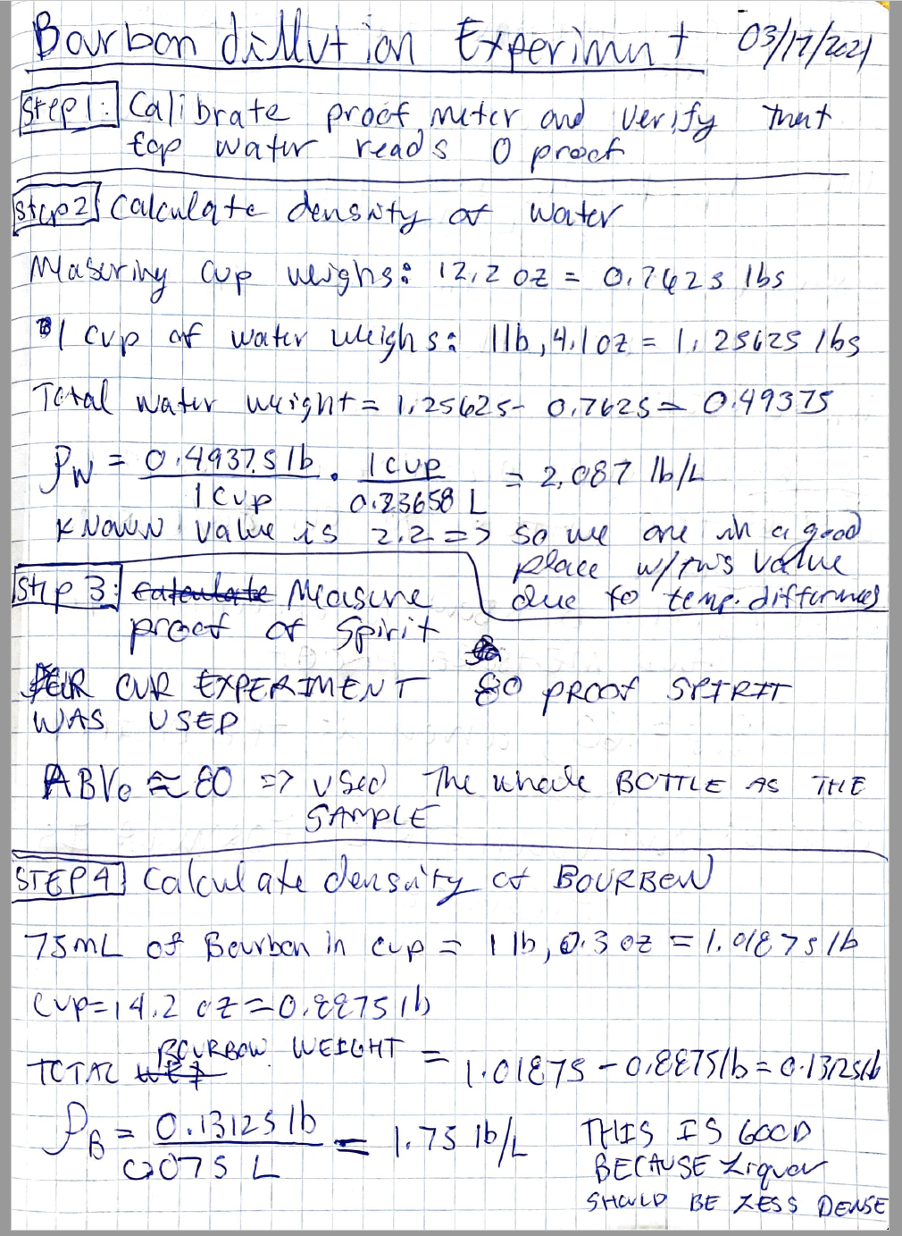

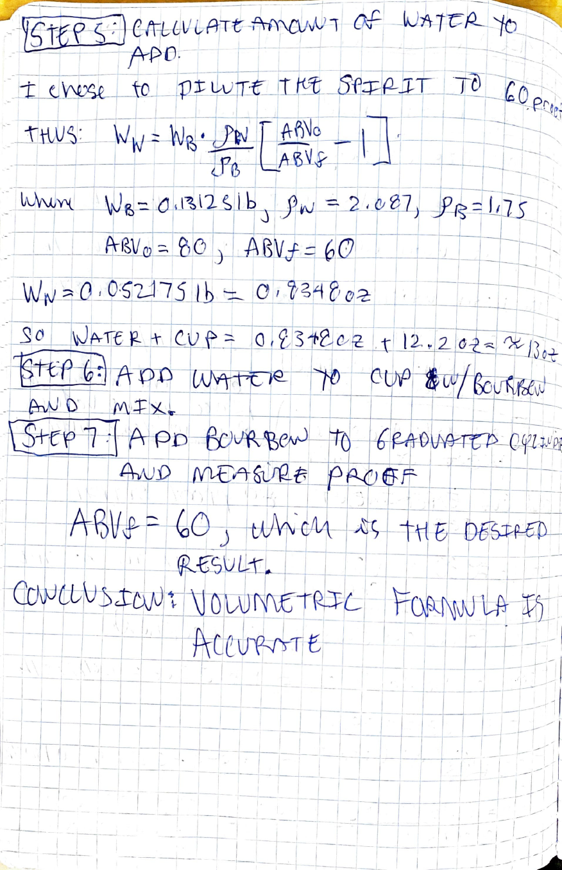

**Figure 1B:** Hand Calculations for the Volumetric Formula

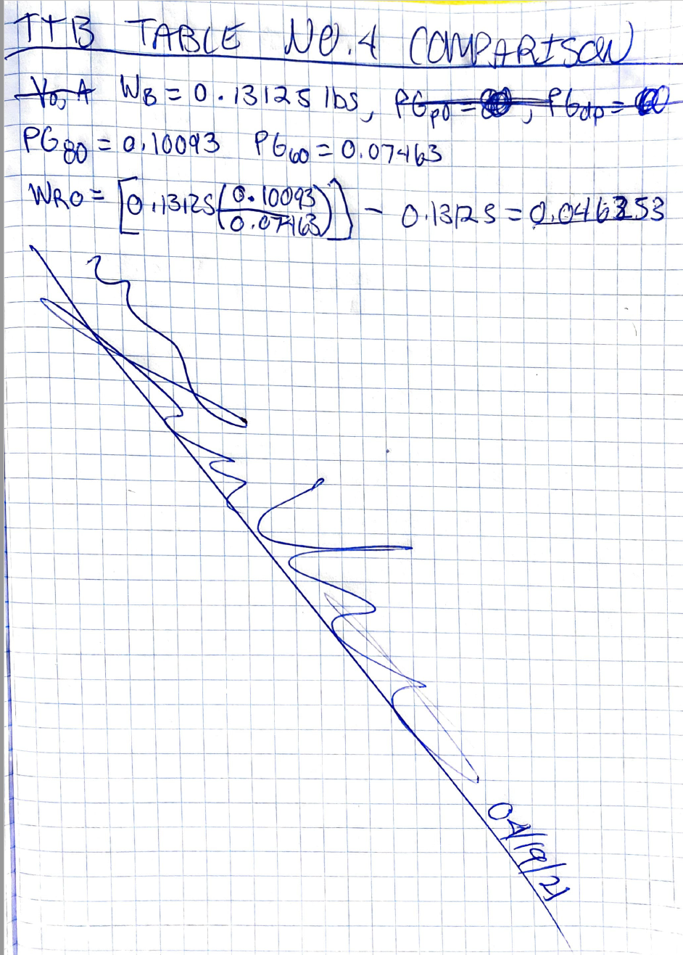

**Figure 2B:** Hand Calculations for Comparison Between Volumetric Formula and Tabular Method